Easy-to-read information about Coronavirus (COVID-19)
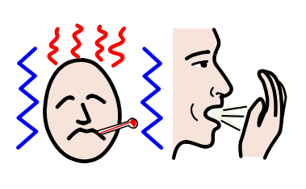
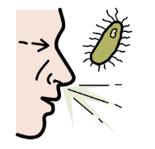
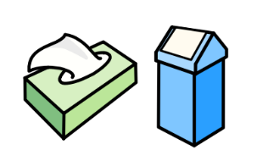
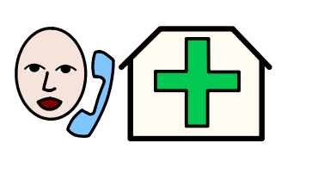  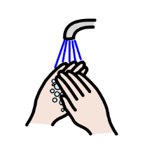 | Coronavirus is a virus that started in China.  It spread to many countries in Europe  and all around the world.  Coronavirus is also called COVID-19.  This is the name of the disease.  People with the Coronavirus disease have:  - a high temperature  - a cough  - a short breath.  Please keep in mind that if you feel this way  it doesn’t mean that you have the Coronavirus disease for sure.  It can also be a normal flu.  You can call the emergency number for Coronavirus  in your country  and explain how you feel.  Call only if you really think  you may have the disease.  There are some things you can do  to not get the Coronavirus disease.  For example:  - wash your hands often  with soap and water  and for 20 seconds at least  - do not touch your face  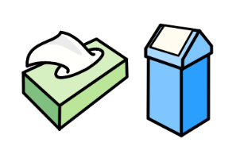  if your hands are not clean  - cough and sneeze in a tissue    and then throw the tissue away  - stay home as much as possible.  The situation of Coronavirus can be different  depending on the country you live in.  Governments are taking different actions  in every country.  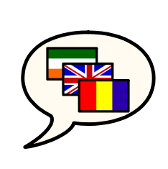  Many organisations of people  with intellectual disabilities  are giving information about Coronavirus  in easy-to-read  and in different languages.  Inclusion Europe suggests you to not panic  and not believe to everything you read on social media.  The best thing to do is to follow  what the experts tell us  about Coronavirus.  Read more information and other resources here.

