Institutionalisation happens in places where people are treated in large groups (based on disability, for example), away from others, their lives directed not by own wishes and needs but by the institution’s rules and protocols.
Namely, segregation happens by location (away from most people, behind fences) and by activity (sleeping, “working”, spending time always with the same people one didn’t choose).
Congregated housing + segregated groups and activities + subjugation to someone else’s rules = institutionalisation.
Logically, deinstitutionalisation is about replacing these elements with support that helps each and every person to be part of the world around them: be part of a family, have friends, have a job, be good at something. To belong.
Universal solutions don’t exist – universal principles do: People seek connections and stability. That must be the guiding principle of any support system.
Support families too, so they don’t have to “choose” between dedicating all energy to one member, or removing them into an institution. With the right support, families can be just that – families. Not full-time carers, therapists, administrators, organisers.
Independence and inclusion are achieved by respecting each and every person’s needs and providing a spectrum of individualised support.
One size does not fit all. This applies to institutions, and in the community. There’s no one service suitable for everyone.
Naturally, deinstitutionalisation guidelines must lead those implementing them to focus on each persons’ inclusion. Establishing a place to live in; job to do; relations to have. Not on houses or services.

People leaving institutions need support establishing relations, learning about outside world and dealing with the consequences of institutionalisation (including support to cope with violence).
Start with those most likely to be left out: people with complex support needs, people with intellectual disabilities. Make the changes and services work for them first.

People with intellectual disabilities not in institutions need support not to end up there. All support must be about establishing independent life in the community based on each person’s needs and choices.
Reforms to child protection must be followed by changes in adult services to avoid people with disabilities who reach adulthood ending up in institutions.
Legal capacity law must change. Supported decision-making become the norm. How can people take responsibility over their lives, when not allowed to decide?

Not to get distracted: Millions in institutions globally and millions more in danger of institutionalisation. Their inclusion must get all attention and resources.
Some people may need “residential care”. What matters is how this is set up, principles it follows, the individual needs; that it leads to inclusion.
User-led quality inspections are crucial, with public, easy to understand results; with consequences for providers.

Family members dedicate their lives providing care and support. Family members started many existing community-based services. Families don’t want their loved ones to be institutionalised. Involving them is critical.

Promote activity and engagement of policy-makers and service providers. Reward changes and progress in the right direction.
Protect legitimacy of deinstitutionalisation. There is no need to play in the hands of the opposition by using terms such as “deinstitutionalisation in crisis”.

Provide policy-makers, funders and service providers with a clear picture of the desired outcome. Trust in their ability to deliver it.
People have different roles to play: be that EU experts, national policy-makers or service providers. They have different needs in how they work and what problems they are solving. This needs to be reflected in guidelines.
Learning from behavioural sciences: What steers people towards institutionalisation? How to turn these choices other way round?
“Changing peoples’ mindset” is the toughest job. Changing the way people work and behave is doable; Minds will follow.

Being included v. being segregated
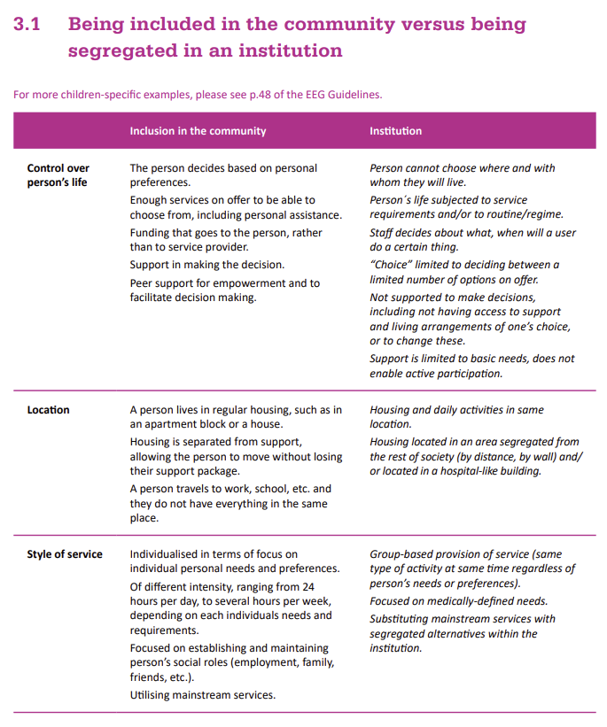

Life after violence. https://www.inclusion-europe.eu/wp-content/uploads/2019/02/LAV-Publication_web.pdf
„In many countries… persons with intellectual disabilities and complex needs are most likely to still live in institutional settings“ https://deinstitutionalisationdotcom.files.wordpress.com/2020/05/eeg-di-report-2020-1.pdf
https://www.inclusion-europe.eu/children-with-disabilities-deserve-a-life-outside-institutions/
https://www.inclusion-europe.eu/what-will-happen-once-were-not-there-anymore-we-think-a-lot-about-it/
Deinstitutionalisation already receives a lot of criticism for “leading to homelessness, abandoning people”. It would be important to be careful about the language.
Checklist to ensure EU funded measures contribute to independent living by developing and ensuring access to family-based and community-based services https://www.inclusion-europe.eu/wp-content/uploads/2015/03/Checklist-to-ensure-EU-funded-measures-contribute-to-independent-living-by-developing-and-ensuring-access-to-family-based-and-community-based-services.pdf

