

**Permission to use my picture**

Explanations for the words in bold are at the end of this text.

I give permission to **Inclusion Europe**to use the picture in attachment.

My picture will be posted on Inclusion Europe’s website,  
and also on their different **social media** channels.

Inclusion Europe might use the picture for one of its publications.

Anyone will be able to see the picture.

I understand that:

* Inclusion Europe will store the picture.  
    
  It will be stored respecting the law.
* I can ask Inclusion Europe to tell me where my picture is stored.
* I can ask Inclusion Europe to delete my picture.

Inclusion Europe will then do this.

But it cannot remove it completely from social media  
if it was already shared there.

If I want to complain about something,  
I can write to Inclusion Europe at

Inclusion Europe

Avenue des Arts 3

1210 Brussels

Belgium

Or [secretariat@inclusion-europe.org](mailto:secretariat@inclusion-europe.org).

Do you agree with everything that is written above?

Then please put here your

___________________________________ ________________________

First and last name Country

___________________ ____________________________________

Date Signature

**Explanations:**

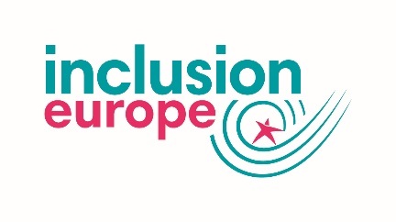**Inclusion Europe**   
  
Inclusion Europe is an organisation for people   
with intellectual disabilities and their families.

Inclusion Europe fights for their equal rights   
and inclusion in Europe.

It also wants to make a difference to the laws in Europe.

It started in 1988.

It has 78 members in 39 European countries.

It is based in Brussels in Belgium.

cid:image014.jpg@01D450D6.C104D5D0**Social Media**Social media is made up of websites and apps   
that let you create and share content.  
  
For example, photos, videos and information.

Apps is short for applications.   
  
These are tools that let you use social media   
on a mobile phone or tablet.