Include
Making EU funds and Disability strategy work
for people with intellectual disabilities and their families
Focus  Both the European Disability Strategy  and EU funding have played a key role  in promoting inclusion, by focusing on issues that might otherwise not get so much attention – such as closing institutions and developing support for independent living and inclusion in the community.  In doing so, the strategy and the funding instruments invite EU member states to address these issues too: by developing their own strategies and modifying national funding to promote inclusion.  This special report offers ideas and topics that should be considered for the next European Disability Strategy, as well as the upcoming EU funding period.  With focus and ambition, much progress can be achieved.  Representing  people with  intellectual disabilities  and their families |  | 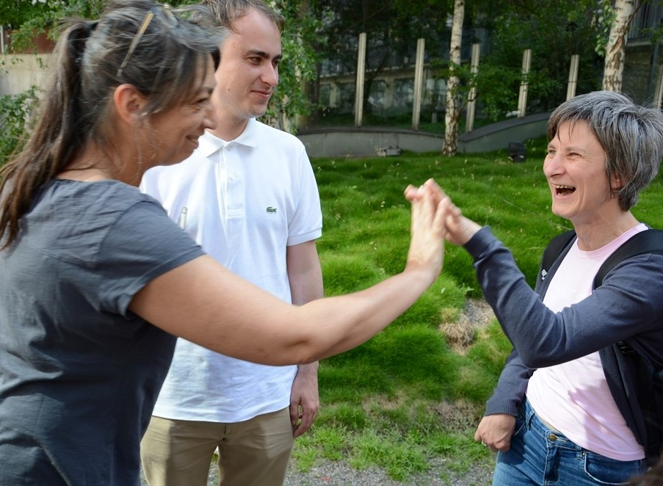  Inclusion Europe Vice-President Senada Halilčević (right-hand side), self-advocacy expert Sandra Marques and board member Harry Roche  Ambitious strategy  “European cooperation is very important and the European Union plays a vital role to strengthen the rights of people with intellectual disability. The European Disability Strategy must be ambitious.” This is the main message Inclusion Europe brings to the discussions about future EU disability strategy. The process of drafting, approving and monitoring the strategy should involve people with intellectual disabilities, for example by providing easy-to-read versions of documents and by organizing inclusive and accessible meetings. “The strategy affects people with intellectual disabilities. They should be in a position to have their say”, says Senada Halilčević, vice-president of Inclusion Europe and a Croatian self-advocate. (Continues at page 2)
continues from page 1  Ambitious strategy  Right to decide. Ending segregation.  The strategy needs to address the issue of legal capacity, which has far-reaching effects on the right of people with disabilities to make decisions about their own life. The strategy should propose specific measures to promote supported decision-making instead of guardianship. “This is essential also to make progress in all priority areas of the current strategy, for instance employment or social protection”, says Milan Šveřepa, Inclusion Europe’s director. In the framework of legal capacity, the strategy should address the right to vote, a right many people with intellectual disabilities in EU countries are still excluded from. Ending segregation The strategy should include clear targets on closing institutions and developing support for independent living and inclusive communities. Tackling violence against women 6 in 10 women with intellectual disabilities report being sexually abused. Violence against women happens in families, in the community and in institutions. Much more needs to be done to tackle it and to support those that have become victims of violence and abuse. Recognising the role of families The strategy should recognise the role of families in supporting the inclusion of people with intellectual disabilities. “It needs to target the discrimination, poverty and exclusion families face”, says Jyrki Pinomaa, President of Inclusion Europe. “These circumstances are not only unacceptable for the people who care for their loved ones – they also directly fall back upon the people with disabilities themselves.” What would you do to make inclusion happen? Elisabeta Moldovan at an inclusion conference  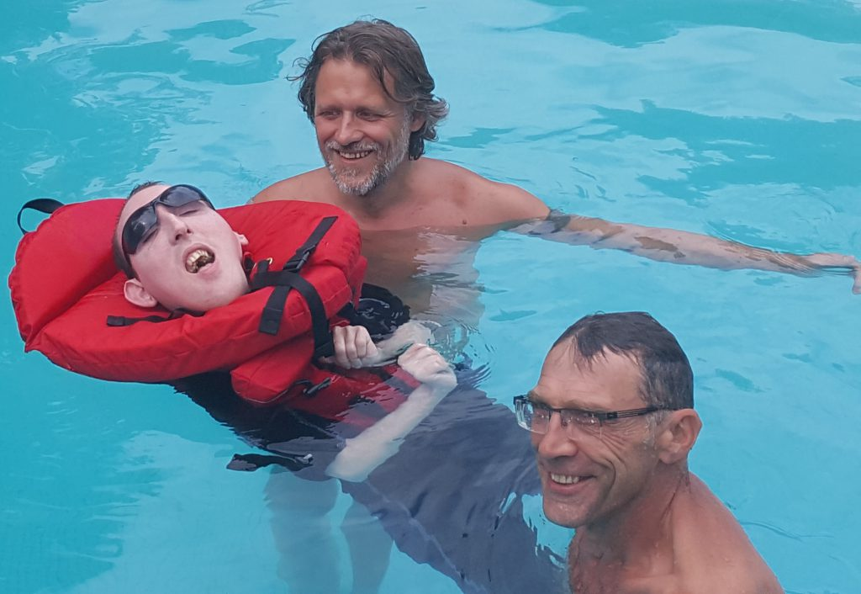  Charles – a young man challenging preconceptions  Read the full story at www.inclusion-europe.eu  The way people look at Charles has changed as his family continues to include him through life’s joys and pains. His life is open to the outside world.  Still, the lack of accessibility of the built environment remains a big barrier. |  |  |  | Being independent and included  New life.  New person?  An example to follow  When Julia moved into her own home we first looked at which support workers she wanted to take with her. There were 5 people she wanted to ask to make this step with her, to this new place, working only with Julia. The people who came were only working with Julia. The aim was to create a good life together with Julia.  Julia is always involved with the interviews of potential new staff. There is also always someone present whom she trusts from her circle and another team member. Nobody is given the job to support Julia after just the first interview. There is always time to reflect and think about the conversation. Then later Julia and the others decide.  Furthermore it is important that someone can listen to what Julia says without using words. And someone has to be interested in exploring the community together with Julia.  Julia indicated she wanted to work at the garden center. Time was needed for them to want her too. We had to start very slowly and carefully. Starting with one hour instead of a whole week. Nowadays, the people at the center would struggle to get through Julia’s holidays when she and her support worker do not turn up. Julia has a valuable contribution to make. That is what we always aim for.  In the 6 years Julia has lived alone she has slowly increased how active her week is. She has come to know many people in her neighbourhood and now has an important role in connecting neighbours to each other.  Read the full story at  www.inclusion-europe.eu.  Deinstitutionalisation  Left behind?  People with complex support needs “have too often been left behind”  “When persons with disabilities are assessed to be requiring high demands for personal service, states often consider institutions as the only solution. That is contrary to article 19, which extends the right to live independently and be included in the community to all persons, regardless of their level of intellectual capacity, self-functioning or support requirement.”  The UN CRPD Committee  Torben Wind, director of LEV, Denmark, says: There are concerns about “re-institutionalisation” of people with complex support needs. New institutions are built.  People with complex support needs are also often left out when plans for the closing of institutions are prepared.
Guardianship law reform in Austria

With the new law, people with intellectual disabilities
are able to decide
There is now a new law in Austria.  The law replaces an old law  about guardianship.  We talked about the new law  with Oswald Föllerer.  Oswald Föllerer is the co-founder  of the Centre for Self-Advocacy in Vienna.  Oswald Föllerer was part of the working group that worked on the new law.  Why were so many people not happy with the Austrian law on guardianship?  Many guardians were lawyers.  These lawyers often did not have  enough time for the people  they made decisions for.  Often, the lawyers  could not be reached easily.  There were examples  where guardians were doing a bad job.  For example, the guardians  did not give enough money  to the people they made decisions for.  Some guardians also managed badly  the things that these people owned.  Sometimes the guardians  sold their things. |  | 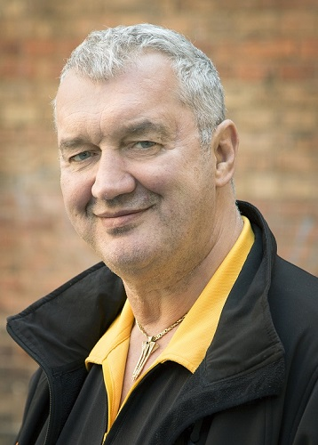  How did the old law influence people’s everyday life?  When a person is under guardianship,  then they often cannot decide freely  to marry or to move in  with his or her partner.  Many people were also told  that they should not have children.  Or they were persuaded  to have themselves sterilised. |  | What does the new law change?  With the new law, people with intellectual disabilities are able to decide.  They now have the right to be listened to  when they decide  who will be their guardian.  Another change is for the guardianship.  It can only last 3 years now.  Then the guardianship can be renewed.  What was it like working  in the inclusive working group  which proposed changes to the law?  The working group met  for 3 years and a half.  The working group was made up of  lawyers, doctors, people working for the state, people with intellectual disabilities or psychological illnesses.  It was often difficult to work in the working group, because there were many difficult words.  After we told them,  they used more texts in easy-to-read.  Taking part in the working group  was exciting.  There were many ideas  how to make things better.
The many kinds of violence women with intellectual disabilities experienced. |  | Talking about violence  It can be done  Interview with researcher Juultje Holla  (full version at www.inclusion-europe.eu)  How did you carry out your research?  Together with a number of self-advocates Ellis and I have made so-called discussion cards that show different types of abuse. The cards help finding out what women with intellectual disabilities themselves perceive as violence, and how this affects their lives.  What else did you do together with the self-advocates?  Together we presented our research to a very mixed group of people with intellectual disabilities and people who worked in institutions. It was only a small group, which allowed for plenty of time for discussion.

Violence against women / Deinstitutionalisation

“My biggest fear is that I will be put back into an institution”
Silence, stigma, not being believed: This is what makes it so difficult to talk about violence against women.  For women with intellectual disabilities, these barriers are even higher – especially if they are living in institutions, segregated from the rest of society, with no one who would listen.  Inclusion Europe’s report “Life after violence” breaks down these barriers: Women with intellectual disabilities who have lived many years in institutions recount their experience and how it influenced their lives.  Unseen and unrecognised. But real  One of the report’s key findings: A big part of the violence women suffer from in institutions is structural and remains unseen. As self-advocate Mirjam Braspenning, who helped conduct the research, says:  “Getting medicine against your wishes, not being allowed to speak up, not being allowed to make your own decisions: All of this is violence. And it adds up.”  As opposed to physical violence, there is no help available, so people adapt in their own ways. |  | Dounia Bouchikhi said:  “People avoid certain situations. They avoid new painful experiences. And they communicate in their own way. One person might get angry, someone else might sleep all day through. But in fact, they are telling you that something is bothering them: We need to listen and try to understand.”  Even women who have moved out of an institution cannot easily forget their negative experiences.  For Mirjam Braspenning, “my biggest fear is that I will be put back into an institution. If I feel good about something I also fear that this good feeling will be taken away from me.”  The report, which is based on in-depth interviews with 10 women, also provides a number of recommendations starting with inclusive education from early age and most importantly putting an end to the institutionalisation and segregation of women with intellectual disabilities. |  | 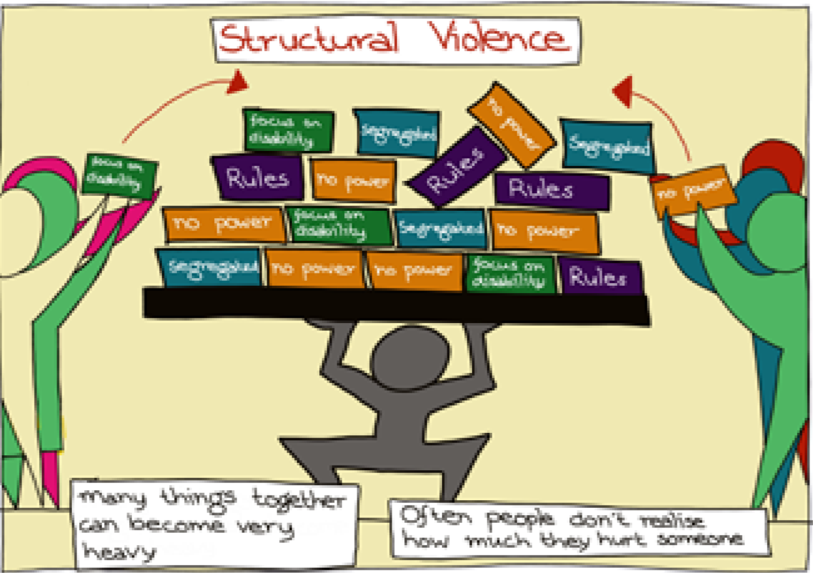  “I am shocked by the terrifying figures and testimonies. Women with disabilities experience violence at higher rates, more frequently, for longer and are less likely to report it. Now it becomes public and there is hope for better combatting it.”  Christine Revault d’Allonnes Bonnefoy, MEP  “Studies such as ‘Life after violence’ are very important to raise awareness on the way women are treated in care institutions. The EU will play a role as a platform where national experiences and measures are exchanged.”  Lambert van Nistelrooij, MEP  “The best way to prevent structural violence is to stop placing people with disabilities in institutions.”  José Smits, Inclusion Europe Secretary General
Right to vote

“What if all people had to do a test to vote?”
This is a question asked by Harry Roche, Board member of Inclusion Europe.  10 EU countries prevent people under guardianship from voting.  And there are many other obstacles to the right to vote: lack of easy-to-read information about elections or the fact that parties often do not reach out to people with intellectual disabilities.  But what can the European Union do to address these issues? Harry Roche had a number of suggestions, for example setting standards for EU elections, developing and sharing expertise in reforming capacity laws and collecting information on the participation of people with disabilities in elections.  Politicians and election authorities should also get advice and training to ensure that materials and meetings are accessible, and meet with self-advocates and organisations that represent people with intellectual disabilities. |  | Harry Roche speaking at the European Disability Parliament about the right to vote

Make the most of the 2019 Elections to the European Parliament

The elections to the European Parliament will happen in May 2019.
These elections are very important for people with intellectual disabilities and their families.
The elections will decide about who will speak for them in the next European Parliament
and if there will be progress on their rights during the next years.

Inclusion Europe prepared a manifesto on how to make the most of the European elections in 2019.

The first two parts are for people who support the inclusion movement: self-advocates, family members and all other activists and European Union citizens.
Part 1: Why are the European elections important?
Part 2: What people with intellectual disabilities, family members and other activists can do

The third part is for political parties and their candidates.
It is also for authorities in charge of organising elections, to help make elections more accessible.
Part 3: What Inclusion Europe thinks the candidates and parties should do for the European elections 2019

Go to www.inclusion-europe.eu and read the manifesto.
It is available in various languages.

Equal rights and full inclusion of people with intellectual disabilities and their families.

More than 70 members in 39 European countries.

@InclusionEurope

facebook.com/InclusionEurope

youtube.com/user/InclusionEurope

Rue d’Arlon 55
1040 Brussels, Belgium
Telephone: +32 25 02 28 15
secretariat@inclusion-europe.org
www.inclusion-europe.eu

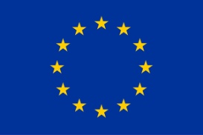

Co-funded by the European Union
This report was funded by the European Union. The EU bears no responsibility for the contents of the report.

