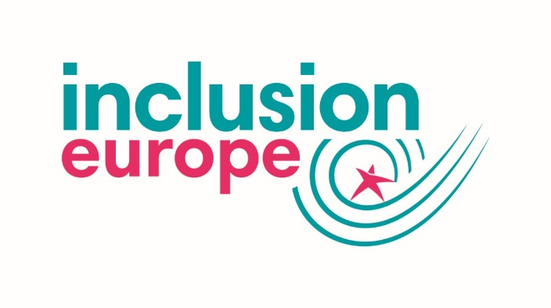
Logo placeholder

I, _________________________________, pledge that if elected as a Member of the European Parliament at the elections in May 2019, I will

- support the movement for voting rights for people with intellectual disabilities in all EU countries

- challenge national authorities to provide information about the elections in an accessible way

- ensure my election campaigning is as accessible, for example by creating an easy-to-read version of my manifesto

- implement the UN CRPD through my voting decisions

- be a strong supporter of an ambitious European Disability Strategy 2020-2030

- advocate for an effective implementation of the European Accessibility Act

- work to make the promises of the European Pillar of Social Rights become a reality

- monitor that EU funds and programmes are used to promote inclusion

- involve people with intellectual disabilities when it comes to disability issues, and beyond

- remind the European Parliament to communicate in accessible ways

______________ _____________________ ____________________
Party Date Signature

