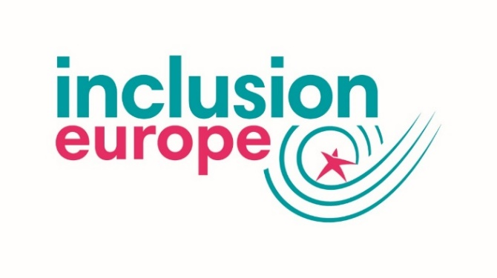
Logo placeholder

I, _________________________________, pledge to support the rights of
people with intellectual disabilities and their families through these actions:

  - support the movement for voting rights for people with intellectual disabilities in all EU countries

  - challenge national authorities to provide information about the elections in an accessible way

  - ensure my election campaign is accessible, for example by creating an easy-to-read version of my manifesto

  - involve people with intellectual disabilities when it comes to disability issues, and beyond

  - monitor that EU funds and programmes are used to promote inclusion

  - demand that the European Parliament communicates in accessible ways

  - advocate for an effective implementation of the European Accessibility Act

  - work to make the promises of the European Pillar of Social Rights become a reality

  - implement the UN CRPD through my voting decisions

  - be a strong supporter of an ambitious European Disability Strategy 2020-2030.

______________ _____________________ ____________________
Party Date Signature

