European Disability Strategy after 2020
The current European Disability Strategy comes to an end in 2020.
Inclusion Europe very much expects the EU will prepare and approve new European Disability Strategy for the period after 2020.
The process of drafting, approving and monitoring the Strategy, and by extension EU policy-making, should involve people with intellectual disabilities, for example by providing easy-to-read versions of documents and by organising inclusive and accessible meetings.
“The strategy affects people with intellectual disabilities.
They should be in a position to have their say.”
Senada Halilčević
self-advocate, former Vice-President of Inclusion Europe
The European Disability Strategy should:
- Address the importance of the right to make decisions;
- Establish clear targets to end segregation;
- Address violence against women with intellectual disabilities;
- Recognise the role of families in fulfilling rights and providing support to their relatives with disabilities;
- Connect to peoples‘ experiences and be easier to understand.
Throughout the strategy, particular attention needs to be paid to:
- Children with intellectual disabilities and their families;
- Women with intellectual disabilities;
- People with complex support needs and their families.

Importance of the right to make decisions
Why?
The deprivation of legal capacity affects all areas of life, and prevents people from voting at elections, participating in the community, deciding where and with whom to live, studying in mainstream education system together with others, taking up an employment contract, or opening a bank account. However, the current strategy does not really tackle this issue and only briefly mentions an improvement in Member States’ legislation on legal capacity in line with the UN Convention. However, it is far from being sufficient.
If legal capacity is not a competence of the EU, it has consequences on social issues where the EU is active, such as employment, citizen’s rights (including the right to vote) and anti-discrimination.
How?
Legal capacity should be a transversal area for action in the EDS as it impacts most of the current priorities’ areas of the strategy. Self-determination, choice and control should be more visible in the new strategy as a pre-requisite to participation and enjoyment of all aspects of life.
“The strategy should propose specific measures to promote supported decision-making instead of guardianship. This is essential also to make progress in all priority areas of the current strategy, for instance employment or social protection” said Milan Šveřepa, Inclusion Europe’s director.” ^{[3]}

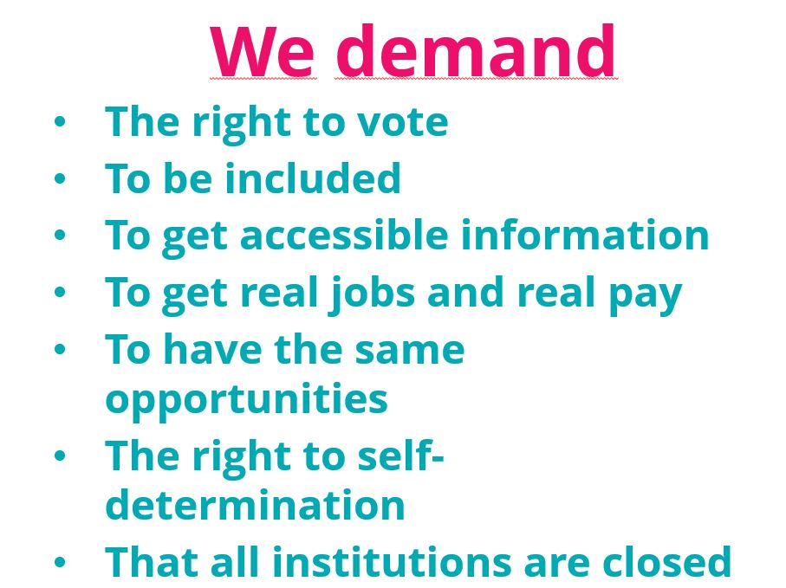

European self-advocates’ demands

Clear targets to end segregation
Why?
The current strategy does not fully address segregation of people with intellectual disabilities in “care” institutions in Europe. It only “promotes” the transition from institutional to community-based services through the use of EU funds and awareness-raising of people living in institutions.
This does not constitute a satisfactory answer to both the CRPD Committee concluding observations and the past work done by the Commission during the previous decade in collaboration with organisations of people with disabilities. It also does not reflect the progress made by the Commission in fighting against institutions through the 2014-2020 Multiannual Financial Framework.
People living in institutions are also systematically excluded from studies, realised by EUROSTAT and are therefore overlooked when formulating policy.
How?
The strategy, while establishing clear targets and objectives, should secure a part of the EU funds to be allocated to the implementation of the EU Disability Strategy 2020-2030. The UN Disability Inclusion Strategy offers a useful example with indicators followed by specific and targeted actions to achieve the goals for each one of the indicators.
Allocate resources to:
- Monitoring the situation of people in “care” institutions and progress towards ending segregation
- Developing incentives for member states to make transition from institutionalisation to community-based support
- Capacity building for participation and monitoring at national level
- Target accessibility of housing or public services such as health care, education; these are critical to make progress on ending segregation

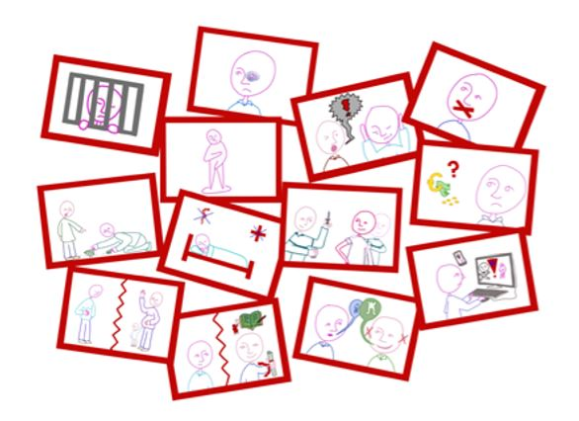

Address violence on women with intellectual disabilities
Why?
6 out of 10 women with intellectual disabilities report being sexually abused.
It is part of the overall problem of violence against women.
But it is also made worse by the additional power imbalance associated with intellectual disability.
Violence occurs both in families and in the community, and it also happens in “care” institutions which claim to protect from it. Being institutionalised is a form of violence in itself.
How?
There should be specific objectives and actions to combat violence against women in the Strategy.
These should include (among others):
- closing down institutions and providing adequate support in the community; providing support to victims of violence with intellectual disabilities.
- Providing training to victim support services to be able to work with women with intellectual disabilities
- Supporting women empowerment and participation in decision-making;
- Educating men in general and persons in power (eg. Service providers) about their responsibilities and about acceptable behaviour

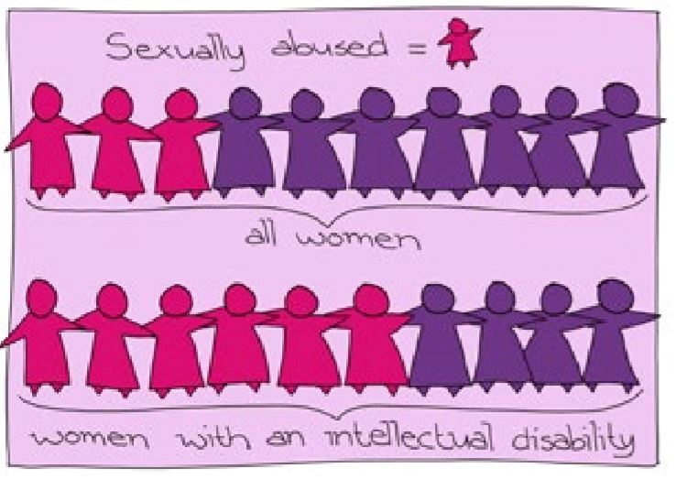

Recognise the role of families in fulfilling the rights of their relatives with disabilities
Why?
Families have a unique role that should be recognised and valued.
Around Europe, families are the main source of support for persons with intellectual disabilities, who often require some form of lifelong support. People with complex support needs and those who do not communicate in typical ways rely, almost exclusively, on their families to support them and articulate their preferences and support needs.
Their crucial role has been underlined by the Committee itself during the key transitional periods in the lives of persons with intellectual disabilities, for example: from childhood to adulthood, parenthood, etc.^{[4]} Because of barriers in community and a lack of support and services to individuals and their families, families experience discrimination and increased economic and social stress.
How?
The strategy should recognise the role of families in supporting the inclusion of people with intellectual disabilities. “It needs to target the discrimination, poverty and exclusion families face. These circumstances are not only unacceptable for the people who care for their loved ones – they also directly fall back upon the people with disabilities themselves.” as said by Jyrki Pinomaa, President of Inclusion Europe.
The strategy should enshrine the right of family carers to be supported through having some of the EU funds allocated for this purpose. A specific target should appear in the strategy on how this goal will be achieved.
Specifically:
- There should be a dedicated section on families and their role
- The strategy should focus on measures supporting families both in having an active role in fulfilling the rights of persons with disabilities, and in receiving support necessary to do so

Connect to peoples’ experiences
and be easier to understand
Why?
It is crucial that people with disabilities themselves feel the strategy is relevant to them, in order for them to get a sense of ownership, believe in it and use it in their countries.
It is important to make the strategy practical and relevant to people’s day-to-day lives. For example, it should talk about the quality of life of persons with intellectual disabilities using data, stories and concrete examples. It could also be a tool to highlight new support models to help families and service providers. Many examples of support can be found on our website.^{[2]}
There should be an easy-to-read version of the strategy.
The Strategy should also ensure existing instruments such as Social Scoreboard are used to their full potential, in order to ensure that data collected to evaluate Members States’ actions for each of the 12 indicators are also disaggregated for people with disabilities and per type of disability.
The EDS should also be better connected to the Sustainable Development Goals (SDGs) and ensure that data regarding people with disabilities, including those living in institutions, are collected and included in the EUROSTAT report on the progress towards the implementation of the SDGs.
Finally, a better connection could be made between the EDS and the European Semester to ensure a regular, annual assessment of Members States as opposed to have a mid-term/final review every five years.

[1] Inclusion Europe’s contribution to the mid-term review of the European Disability Strategy, 2016
^{[2]} https://www.inclusion-europe.eu/europe-in-action-hundreds-meet-in-vilnius-to-discuss-independent-living-for-people-with-intellectual-disabilities/
[3] Special issue for the European Day of Persons with Disabilities in December 2018
^{[4] CRPD Committee,}

More information and recommendations https://www.inclusion-europe.eu/wp-content/uploads/2019/02/LAV-Publication_web.pdf
https://www.inclusion-europe.eu/wp-content/uploads/2019/02/LAV-Publication_web.pdf

