**Easy-to-read information about Coronavirus (COVID-19)**

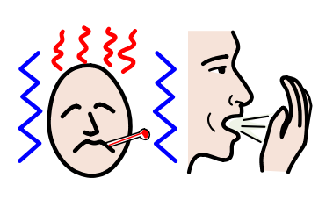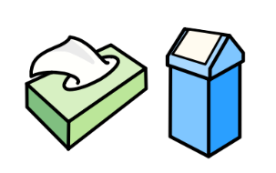

|  |  |
| --- | --- |
|  | Coronavirus is a virus that started in China.  It spread to many countries in Europe  and all around the world.  Coronavirus is also called COVID-19.  That is the scientific name of the virus.  People with Coronavirus have:   * a high temperature * a cough * a short breath.   Please keep in mind that if you feel this way  it doesn’t mean that you have Coronavirus for sure.  It can also be a normal flu.  But you should call an hospital  and tell the doctors and nurses how you feel.  There are some things you can do  to not get the Coronavirus.  For example:   * wash your hands often   with soap and water  and for 20 seconds at least   * do not touch your face   if your hands are not clean   * cough and sneeze in a tissue   and then throw the tissue away.  The situation of Coronavirus can be different  depending on the country you live in.  Governments are taking different actions  in every country.  Immagine che contiene disegnando, specchio, gioco  Descrizione generata automaticamente  Many organisations of people with intellectual disabilities  are giving information about Coronavirus  in easy-to-read  and in different languages.  Inclusion Europe suggests you to not panic  and not believe to everything you read on social media.  The best thing to do is ­to follow  what the experts tell us  about Coronavirus.  [Read more information and other resources here.](https://www.inclusion-europe.eu/coronavirus-pandemic/) |

