**What is “social distancing”**

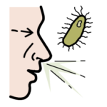With the [Coronavirus](https://www.inclusion-europe.eu/easy-to-read-information-about-coronavirus/),

everyone speaks of “social distancing”.

What does “social distancing” mean?

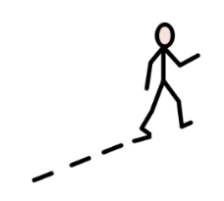Social distancing means that

we need to keep away one from each other.

Staying away from other people stops the virus

from making more people ill.

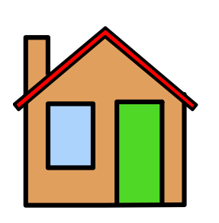

This means that people are told to   
work from home and not to come to workplace.

This also means day centres may be closed and people with disabilities are asked to stay at home.

This also means restaurants can be closed.

And events like parties or conferences are cancelled.

It can be hard to be isolated.

It is important to talk to other people   
during social distancing.

You can do that using phone or online calls.

**How to talk to other people online?**

To stay connected to the people we like

and to continue our work,

we can use other forms of communication.

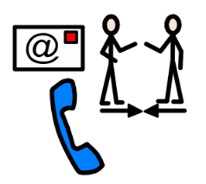For example:

* Phone calls
* [**WhatsApp**](https://www.whatsapp.com/)
* [**Skype**](https://www.skype.com/fr/get-skype/)

There are also apps people use to organise online meetings of bigger groups of people:

* [Microsoft Teams](https://products.office.com/en-US/microsoft-teams/group-chat-software)
* [Zoom](https://zoom.us)

[Find more information about Coronavirus here.](https://www.inclusion-europe.eu/coronavirus-pandemic/)