5 steps to prevent harm
to people with intellectual

disabilities and their families
in Coronavirus emergency.
Help
now
Inform clearly
Prevent further harm

- Inform clearly about what people should do to protect themselves  and others.  - Deliver the information  to people with intellectual disabilities and their families. | - Help to deal with emergency, limited services  and crisis plans.  - Help to overcome isolation  while social distancing measures are in place. | - Protect disability rights and related funding.
There are recommendations, examples and practices for each of these 5 steps.
Use them!

- Inform clearly.

Easy to understand information is important.
Especially when there are many, often conflicting, news and information.

Tell people clearly what they need to do to protect themselves and others.
Provide a phone number and email address where people can get more information.
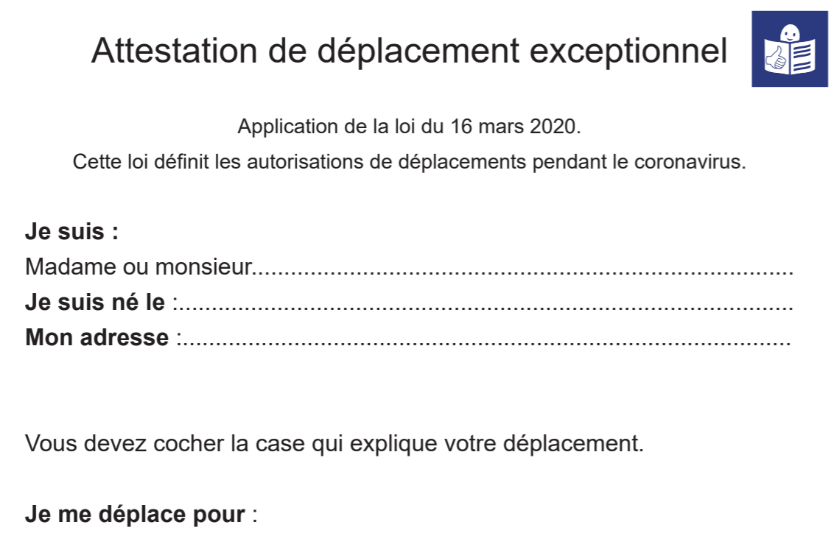

Here are:
- Examples of easy-to-read about the Coronavirus.
- How German government is using easy-to-read
- More information on easy-to-read is and how to produce it.

Easy to understand is not only about written text.
Video can also be produced in that way. We have examples.

- Deliver the information.

Producing the information is one thing, delivering it to those who need it is yet another.

Reach out to organisations of people with intellectual disabilities and ask them for help to get the information out.

We can also help spread the message:
- comms@inclusion-europe.org
- Facebook
- Twitter
- LinkedIn

Ensure accessibility of apps, websites and phone-lines providing support during the emergency.

- Help to deal with the emergency.

Provide protective equipment to people with disabilities and to those who support them:
Does your distribution reach families of children and adults with disabilities? And residential services?

Many day-care centres are closed.
This means families taking over and being exposed to many risks: loss of income, high levels of stress and other consequences.
Look for ways to support them.
Apply emergency social security measures to families caring for people with disabilities, including adults.
Support people with disabilities and families in crisis planning and arrangements.

If you take part in voluntary activities such as grocery shopping for others, please consider people with disabilities and their families.

Learn what countries and organisations are doing for people with disabilities.

- Help to deal with isolation.

Do you organise online activities to help people overcome social isolation?
Please reach out to people with disabilities and families.

Do you provide online learning tools for children out of school? Are you involving families of children with intellectual disabilities?
“People with disabilities feel they have been left behind.
Containment measures, such as social distancing and self-isolation, may be impossible for those who rely on the support of others to eat, dress and bathe."
Catalina Devandas, UN Special Rapporteur on the rights of persons with disabilities

- Protect disability rights and related funding.

We have noticed attempts by some governments to use the Coronavirus emergency as a cover to restrict the rights of people with disabilities.
That is not acceptable.

Protect the rights of people with disabilities in all actions taken to deal with the pandemic.
This includes providing non-discriminatory medical guidance.

Ensure the emergency measures taken to support people and businesses include people with intellectual disabilities and their families, disability organisations and service providers.

Avoid any cuts to disability-related funding, such as to disability benefits, social services or disabled people organisations.

5 steps to prevent harm to people with intellectual disabilities and their families in Coronavirus emergency.
- Inform clearly  - Deliver the information | - Help to deal with emergency  - Help to overcome isolation | - Protect disability rights

