What to do during Coronavirus isolation?

During this period of isolation,
where everyone should stay at home,
it's possible to feel lonely,
and bored.

There are several solutions for this.
We can:

- Read books

Free audio books,
Click here.

- Draw

Models of mandala designs to print out
on this link.
Other drawings here.

You need to print them out.

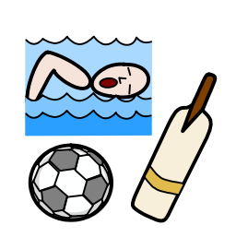 | - Sports at home  We can do some sports,  - Yoga  - Workout  - Pilates  - Dance
- Watch movies
There are many ways to watch movies.

There is of course Netflix.

But also the Television.
There might be some special programs.

The website Openculture
broadcasting more than
700 movies freely.

- Opera

During that time,
the Paris Opera has decided
to make available free of charge
its shows
on this link.

- Sing

Link to Karaoke songs

- Listen to Music

There is of course YouTube.
But you can also listen to classic music,
and not only on the Philharmonie de Paris.

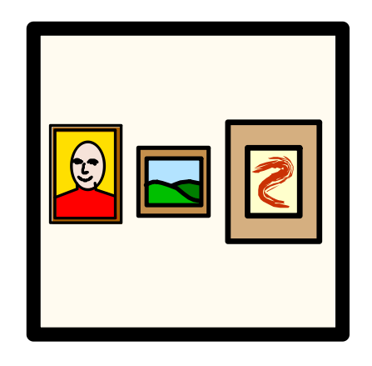 | - Museums  It is possible to do  virtual tours of museums.  This means that you can visit a museum  while staying at home  by clicking on this link.
- Craftwork
Like salt paste modelling dough !
The recipe is on next page.

Salt paste modelling dough

- In a bowl, put 1 glass of salt and 2 glasses of flour.

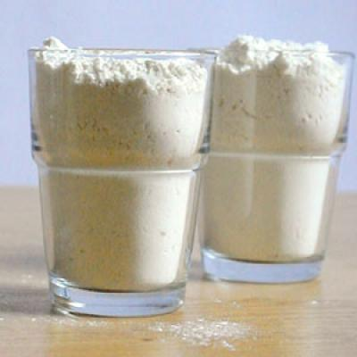 | + | 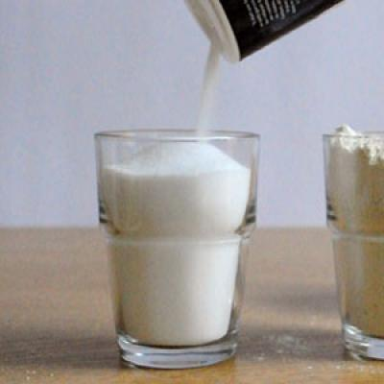
2 glasses of flour |  | 1 glass of salt

- Mix with your hands
the salt and the flour
in the bowl.

- Add 1 glass of water
in the bowl.

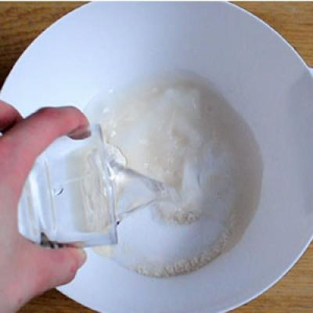

- Mix with your hands
until you have
a ball of dough.
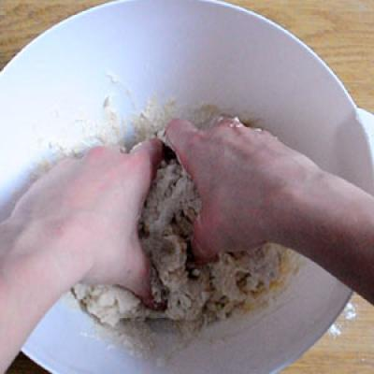 | 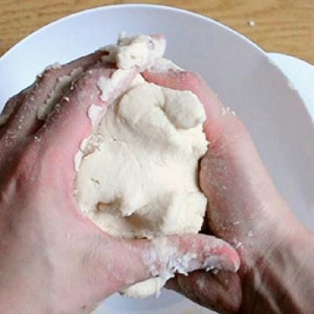 | 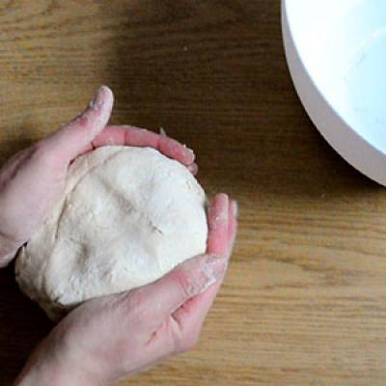
The beginning | Still a bit more … | And there you have a nice ball !
- You can then do some forms
like snails,
a ladybird,
an octopus,
and many others …

- Then you must leave it dry
for 12 hours
in a dry place.

- You can then put it in the oven
at low temperature (75°C to 100°C),
for 1 hour.
And let it cool down after.
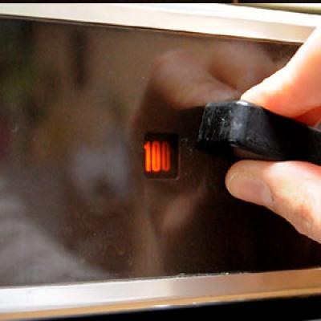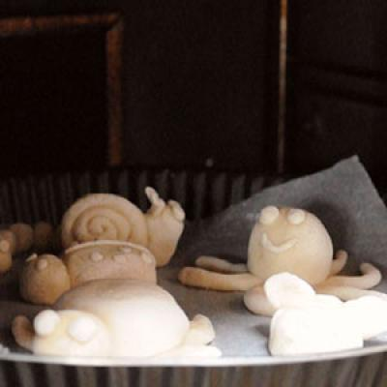

- You can then paint them !
