**Neglect and discrimination. Multiplied  
How Covid impacted rights of people with intellectual disabilities and families in Europe**

Conference of State Parties 2020 side event contribution   
by **Soufiane El Amrani** and **Milan Sverepa**

[Read our full report on the situation.](https://www.inclusion-europe.eu/covid-report-2020-etr/)

Soufiane El Amrani is easy-to-read   
and advocacy expert at [Inclusion Europe.](https://www.inclusion-europe.eu/tag/soufiane-el-amrani/)  
Soufiane works with the [European Platform   
of Self-Advocates](https://www.inclusion-europe.eu/european-platform-of-self-advocates-epsa/) for many years.  
Soufiane is at Council of Inclusion International   
since November 2020.

****Milan Sverepa is director of [Inclusion Europe](https://www.inclusion-europe.eu/tag/milan-sverepa/).   
Milan helped to close segregated care institutions   
and to develop community-based support   
in European countries.  
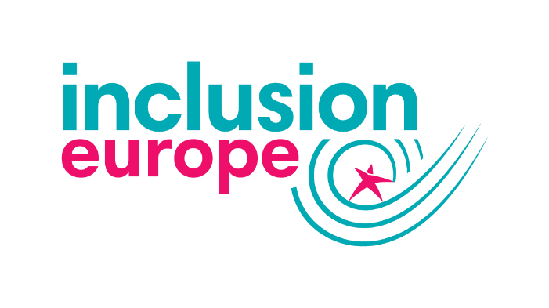Inclusion Europe is the European movement of people with intellectual disabilities  
and their families.   
Inclusion Europe has members in 40 European countries.  
Inclusion Europe represents over 20 million citizens.

During the Corona crisis, persons with intellectual disabilities   
had to adapt, like everybody else.

Families had to adapt.

Service providers had to adapt.

You really have to admire the people with intellectual disabilities, the family members supporting them, the staff in services.

As a self-advocate, I was able to do a lot of tasks.

I was in contact with other self-advocates across Europe.

This was different for many people with intellectual disabilities   
in Europe.

Many thousands have faced complete isolation,   
especially those segregated in residential care institutions.

The pandemic means losing support networks.

Not being able to see our family and friends.

Not being able to go to work.

In some countries, people were left without support.

Students with intellectual disabilities were left out of school, online classes were not accessible to them.

It was hard to stay connected and working.

Online meetings or calls are not for all people.

Some people do not have the computers or the phones to do it.

Some people do not have internet connection.

Many people with intellectual disabilities have lost their jobs.

Many of us feel that we were left out.

Our needs were often not considered   
when preparing the measures and solutions.

Information was mostly not accessible to us,   
provided only in difficult language.

We often could not understand what was going on.  
What do we need to do and why?

Persons living in institutions were not able to   
get out for a long time.

Many still aren’t.

Many people with intellectual disabilities were denied proper health care when sick with Covid.

Many people with intellectual disabilities died   
from the Coronavirus.

In England, they died at 3 times higher rate   
than the general population.

How is it in other countries?

Especially where there are a lot of people   
in residential care institutions?

We don’t know,   
because other countries do not report this information!

It is important to understand that the bad things happening during the pandemic are not new to us.

People with intellectual disabilities and families already faced segregation, isolation, lack of health care…

The pandemic made existing problems,   
discrimination and segregation worse.

The pandemic also made the problems easier to see   
– we hope also for the governments.

**What needs to be done now?**

Governments must learn from these experiences and failures.

They must listen to people with intellectual disabilities   
and families when preparing the measures.

Governments and the European Union must investigate properly the things that happened to people with intellectual disabilities.

How many died?   
How many died because they did not receive   
proper medical care?

The European Parliament [also called for protection](https://www.inclusion-europe.eu/european-parliament-in-defence-of-people-with-intellectual-disabilities-covid19-etr/)  
of the rights of people with intellectual disabilities.

Governments must provide easy-to-understand information.

Some have been doing that,   
others can learn from their example.

The European Union and national money   
for economic recovery must reach people   
with intellectual disabilities and families.

The money must go into support,   
especially in inclusive education   
and in employment for people with intellectual disabilities.

The money must go into community-based services.  
People with intellectual disabilities must be able   
to move out of the segregated residential care institutions!

[Read the Inclusion Europe report on the situation.](https://www.inclusion-europe.eu/covid-report-2020-etr/)

Follow Inclusion Europe on [Twitter](https://twitter.com/InclusionEurope) – [Facebook](https://www.facebook.com/inclusioneurope) – [LinkedIn](https://www.linkedin.com/company/inclusion-europe) – [Instagram](https://www.instagram.com/inclusioneurope/) – [Youtube](https://www.youtube.com/channel/UCbMENufeAkmK_jrDmMWV-xA).

Subscribe to Inclusion Europe [newsletters.](https://www.inclusion-europe.eu/subscribe-to-our-newsletters/)