Europe for us 3

Employability and education

Contents

Editor's note

Important decision by the European Parliament on the rights of people with disabilities

Unfair situations during quarantine that show the world is not designed for people with intellectual disabilities

“Education is a right to be fought for”

Inclusive society can be more than a sweet dream

“We need to change the way we look at education”

Videos supporting employment of people with intellectual disabilities

Ivo Vykydal, former president of Inclusion Europe, died aged 56

Editor's note

Hi my name is Soufiane El Amrani.
I am the easy-to-read editor at Inclusion Europe.

I am going to tell you about some of
the articles that you will find in this Europe for us newsletter.
- Important decision made by the European Parliament on the rights of people with disabilities.
- The ABCs of Inclusive Education
- Education is a right to be fought for

All these articles I have talked about are very important.
Thanks, from Soufiane El Amrani
Easy to read editor and self-advocacy officer

Important decision by the European Parliament on the rights of people with disabilities

On July 8th, the European Parliament approved a
decision in defence of rights of people with
intellectual disabilities in times of COVID-19 crisis.

This decision is based on a petition from Inclusion Europe.
The petition calls for measures that protect
people with intellectual disabilities
during and after the COVID-19 emergency.
During the COVID-19 emergency,
several European countries
did not respect the rights
of people with intellectual disabilities.

For example, there has been
medical discrimination in hospitals.
It means that people with disabilities
could not have access to healthcare.

László Bercse supported the petition.
László Bercse is the Vice-President of Inclusion Europe
and the chair of EPSA.
He said:
“we need to make sure
our rights are respected and that
we are not left behind.”

The European Parliament approved the resolution by
- 682 votes in favor,
- 3 against,
- 10 non-voting.

The European Parliament recalls that
post-coronavirus measures must be compatible with
- the European Charter of Fundamental Rights,
describing all the rights of being a human in Europe;
- the UN Convention on the Rights of Persons with Disabilities.

The European Parliament also requests that
all information about COVID-19 are:
- easy-to-read,
- easy-to-understand.

Jyrki Pinomaa is the
President of Inclusion Europe.
He is very happy about the
decision of the European Parliament.

He appreciates that the European Parliament reassured
people with intellectual disabilities and their families
about their rights to have access to healthcare.

Helen Portal is the Policy Officer of Inclusion Europe.
She said that this vote is important to
address the harm and damage done
to people with intellectual disabilities.
Click here to find more information
about our petition.

Unfair situations during quarantine that show the world is not designed for people with intellectual disabilities

The world is not designed for people
with intellectual disabilities.
We will tell you about several situations
that have been happening during quarantine
that prove it.

The government banned people
from going out on the streets.
But they forgot that there are people who feel stressed
if they do not go outside for a while.
Then the government gave permission to these people go outside.

Many people with disabilities live in residential institutions.
It is difficult to avoid infection in residential institutions.
It would be better if they lived in apartments
with fewer people and in the community
like all the people without disabilities.

Schools have closed.
Schools are sending homework online,
but many people forgot
that people with disabilities can
have a hard time using technology.
People with intellectual disabilities
are being left out of education.

It is hard to understand
the information about the coronavirus.
This shows that the government and the media
forgot about people who have a hard time understanding things.

Many people are using technology
to work and to connect with their families and friends.
Technology is hard to understand,
so people with disabilities and their families
have a difficult time to connect with their families and friends.

Article by Sofía Reyes, Amalia San Román and Olga Berrios,
who are part of Plena Inclusión (Spain).

“Education is a right to be fought for”

Maria Alexandrova is an 18-year-old student from Bulgaria.
She lives with cerebral palsy.

Cerebral palsy is a group of disorders that
affect person’s ability to move.
Cerebral means having to do with the brain.
Palsy means weakness or
problems with using the muscles.

Maria speaks perfect English.
But she could not take the Cambridge Assessment English because it was not accessible to her
with her physical disability.

The Cambridge Assessment is an English exam
organized by the University of Cambridge.
It is recognized by employees and universities
as proof of ability to speak English.
There are exam centers in 130 countries.
Maria moves her arms more slowly than her peers.
So, it was more difficult for her to complete the exam
in the limited time required.

Maria asked the University of Cambridge to
adapt its Advanced English examination
to her needs.

For 3 months, she advocated for
different examination conditions to
give her equal chance of gaining this certificate.
The only difference she advocated for was
for the writing module of the exam.
She would be using a computer instead of a notepad.
Maria never gave up.
She said:
“If you have the drive to accomplish something,
there is nothing impossible.”

The examining centre finally agreed to
- change the timing of the exam,
- let her use a computer.

Weeks later, she successfully passed the exam.
She has become the first person with disabilities in Bulgaria
to receive this English certificate.

Maria said:
“Some people take education for granted,
simply because it was given to them.
But for people like me,
education is a right to be fought for”.

Her fight allows other students with disabilities
- to take the exam,
- to increase their chances of going to university and finding a job.

You can watch her story
with English subtitles here:
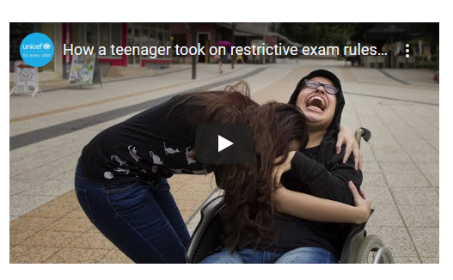

Inclusive society can be more than a sweet dream

Christine Dufour is the founder
of an NGO in Brussels.
She has a daughter with intellectual disabilities.
Her name is Lisette.

Inclusion Europe did an interview with Christine Dufour.
She spoke about how inclusive education
is good for everyone.

How was the NGO founded?
The creation of the NGO was needed
when I realized that Lisette needed help in the classroom.

Lisette has been attending
mainstream school since the age of 3.

But I realized that it was essential to
put in place something that could help her in her learning.

Then, I looked for someone who wanted to help Lisette
understand the instructions, and
adapt teaching materials to her needs.

A volunteer agreed to help my daughter in her classroom.
This was a real help for Lisette and her teacher.

That is how I came up with the idea of creating the NGO
to help other children with disabilities to be included at school.

What does your NGO do?
The NGO sets up individual
support within mainstream schools.

A volunteer helps a child with disabilities in the class and
becomes a support for the child and the teacher.

To this date, the NGO has about 60 volunteers,
who help about 60 children with disabilities.

Do you have any future projects?
We have the project to create an inclusive school.
This school would welcome:
- children with disabilities,
- children without disabilities.

Teachers would
- use new teaching methods,
- be trained to supervise any child with complex support needs.

What are the benefits of inclusive education?
Inclusion of children with disabilities is good for everyone.
Children with support needs are pushed to do better.
Their inclusion in the class brings tolerance and empathy.

It is also a benefit for the teachers.
They are encouraged to adapt their learning methods
to the needs of every child.

How does Lisette experience her inclusion in mainstream school?
Being included at school helps Lisette understand
the behaviors that are good
and the behaviors that are not.
She starts reading, and
she loves mathematics.
She is interested in many things.
Inclusive education plays a big role in all of this!

Her inclusion at school is good for her
but also, for the other children.
The children develop a sense of mutual aid,
and the teacher does not have to impose it!

What needs to be done for schools to be truly inclusive?
Schools must have enough
money and people to help
implementing inclusion in classrooms.

The school system must also adapt
to the needs of each child,
not the other way around!

“We need to change the way we look at education”

Anne-Marie Callus is a lecturer at the University of Malta.
She lectures and researches about inclusive education.

Inclusion Europe did an interview with Anne-Marie Callus.
She explains the importance for all children
to receive a quality education.

How do you define inclusive education?

Inclusion is about asking what we need to do
to adapt the mainstream education setting
to meet the individual needs of students with disabilities.
What are the long-terms effects of inclusion at school?
Having students with and without
disabilities in the same classroom
is an important step towards
achieving inclusion in society.
If children with disabilities are
sent to segregated schools,
they will be excluded from society
when they are adults.

If children with disabilities are
included in mainstream schools,
they will be most probably
socially included as adults.

How can inclusion of students with intellectual disabilities at university be improved?
Universities need to work
with self-advocacy organisations.

Together, they can examine:
- what the learning needs of
students with intellectual disabilities are;
- what wishes students with
intellectual disabilities have;
- what the university can offer
to meet these needs and wishes.

What is the space allocated to the voice of students with intellectual disabilities in inclusion?

All students with disabilities should have a voice
in the planning of their education.
It is often assumed that students
with intellectual disabilities
cannot represent themselves.
So, they are often excluded
from the discussion about education.

But they cannot learn
how to make choices and express their wishes
unless we give them the opportunities to do so.

What are the consequences of
the COVID-19 crisis on education?

With schools closed, the use of
online platforms and other tools
of distance learning are very valuable resources.

But some students do not have
adequate support at home.
So, they are at risk of losing
out their education.

Do you think distance learning can
be negative to the education experience
of students with intellectual disabilities?

Distance learning is a very valuable resource.
But it cannot replace the experience
of students being
in the same class together
with their teachers.

Students with intellectual disabilities
require one-to-one support.
It is difficult to provide this support
through a computer screen.

Videos supporting employment of
people with intellectual disabilities

Most people with intellectual disabilities do not work.
Those who work often do not get a fair salary.

The “My Talents for Diversity” is a project
that tackles this issue.
We call it MTFD for short.
The project is led by Inclusion Europe and 3 partners:
- Plena Inclusión (in Spain),
- EVPIT (in Estonia),
- Antwerp Management School (in Belgium).

They have produced videos to share examples of companies
that employ people with intellectual disabilities.

Follow Thibeau on his working day at Antwerp Management School

Thibeau woks at Antwerp Management School in Belgium.
He is a researcher for the MTFD project.

His job consists in interviewing people in companies
that employ people with intellectual disabilities.

Thibeau can count on the help of two colleagues that
support him with practical matters.
You can watch the video here:
https://youtu.be/aADuqI3ICkw

Customised employment for Manuela

Manuela Cambreiro has been working
in a market in Tenerife for many years.
Ana Peña is a job coach.
Hugo Pérez is a supermarket manager.
Together, they have created a customised job for Manuela.
Manuela’s job has been created according to:
- her skills,
- the things that she enjoyed,
- the needs of the market on site.
You can watch the video here:
https://youtu.be/4hVg4K65KCA
Reasonable accommodations at OACEX
OACEX is an office in Spain.

Aroa Rico is an employee at OACEX.
When she started, she received an easy-to-read version
of the manual explaining the functioning of the company.
With reasonable accommodations,
people with intellectual disabilities can work with
the same autonomy as any other employee.
You can watch the video here:
https://youtu.be/czpb3iBxWsE

How having a job coach helped Laura to achieve her dream?

Job coaches provide support to employees
with intellectual disabilities
when they start a new job.

Laura Pereira Barahona has been working as
an administrative assistant for nearly 5 years.

Her job coach accompanied her from the start to help her understand
- the job,
- the tasks,
- the functioning of the company.
You can watch the video here:
https://youtu.be/rHlB9FYO-t0
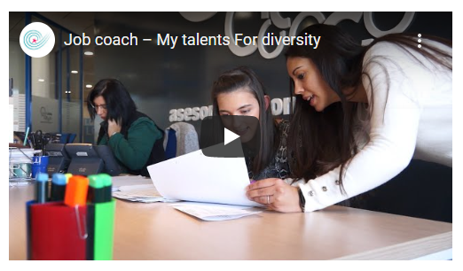

Follow Toomas during his specialised training

Toomas Niitepõld is employee
at Rimi supermarket chain in Estonia.

Before starting his job, he received a training of
job environment and security.
His working tasks and duties were taught
onsite by elder colleagues.
You can watch the video here:
https://youtu.be/UejuuWzFThk
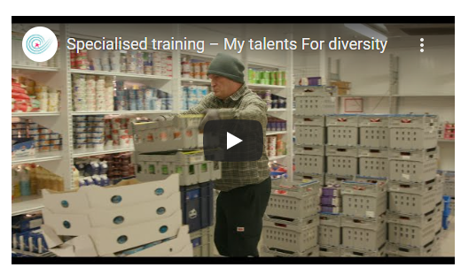

How are families important in supporting people with intellectual disability to work?

The process of entering the job market
is supported by the family of people with disability.

The families provide support regarding
the hopes and abilities of the person’s employment future.
You can watch the video here: https://youtu.be/KdJdme1GsP4
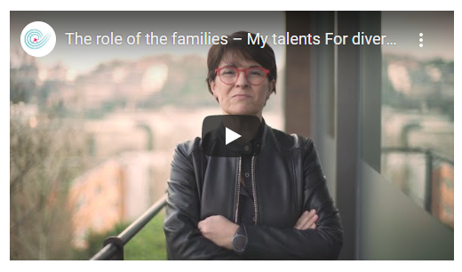

Ivo Vykydal, former president of Inclusion Europe, died aged 56

Ivo was a board member of
Inclusion Europe since 2008 for 5 years
and also, as Secretary-General before.

He worked on the first EU Disability Strategy and
the Children’s rights for all (.pdf) report.

Ivo Vykydal served also as the
president of Inclusion Czechia
between 2002 and 2011.

Ivo Vykydal was a member of the
Czech Parliament in 2002-2006.

Inclusion Europe expresses sincere
condolences to Ivo’s family and friends.

Jyrki Pinomaa, president of Inclusion Europe, said:
“It is with great sadness that I have received
the news of Ivo Vykydal’s death.
My thoughts go to his wife Karin
and his children, who have lost their
husband and father far too early.”

Maureen Piggot, Inclusion Europe
president 2011-2018, said:
“I was shocked and saddened to hear of
Ivo’s untimely death. It is a sad day for his family,
his country and the Inclusion family,
which he served at national,
regional and global level.

Explanations

Accessible
Something that is easy to use for people with disabilities.
Such as:
- Ramps to get into a building.
- Information in easy-to-read.
- Information in sign language.

Commissioner at the European Commission
A Commissioner is a person who is responsible
for a field of work at the European Commission
and manages a lot of people.

Discrimination
Discrimination means that you are treated worse than others or
that you do not get the chances you deserve.

It is discrimination when it happens because of your disability.
It can also happen to other people.
For example, people who have a different skin colour.
Or older people.

Easy-to-read
Easy to read is information that is written in a simple way
so that people with intellectual disabilities can understand.

It is important to use simple words and sentences.
If there are words that are difficult to understand,
an explanation is provided.

The text needs to be clear to see,
for example, black writing on a white background is good.
It needs to be well-spaced.

Easy-to-read often uses pictures
to explain what the text talks about.

Someone with an intellectual disability needs to
check the information is easy to understand.

Easy-to-read documents often have this logo,
so it is easier to find them.
There are rules on how easy-to-read should be done.

Educate
Educate means to teach.
It means to make sure people have access to training
so they can learn new skills.

EPSA
The European Platform of Self-Advocates
is made up of organisations of self-advocates
from different countries in Europe.
We call it EPSA for short.
It is a part of Inclusion Europe.

European Commission
The European Commission works
with the European Parliament.

The European Commission suggests laws
for the European Parliament
and the Council of the European Union to discuss.

It also makes sure that the laws
that have been decided upon
are being followed by the member states.

European Parliament
The European Parliament is a place where
important decisions of the European Union are made.
For example: laws.
The Members of the European Parliament (in short, MEPs)
make these decisions
and speak for all the people
who live in the European Union.

Every five years,
the people who live in the European Union
vote for their country’s MEPs.

European Union
The European Union (in short, EU) is a group of 28 countries.
We call these countries “member states”.
They have joined together
to be stronger politically and economically.

The EU makes laws on many important things for the people who live in
those countries.
The EU makes laws in different areas. Some examples are:
- Laws to protect the environment.
- Laws for farmers.
- Laws to protect consumers.
A consumer is someone who buys things.
The EU also makes laws that are important
for people with disabilities.
It also made a law that gives people with disabilities
more rights when they are travelling.

The EU also gives money to its member states.
Some of this money is used for people with disabilities.

Government
A government is a group of people
that make decisions on how to run a country.
For example,
- about where the money is spent,
- about public transport,
- about schools,
- about hospitals.

Every few years there are elections
to vote for a new government.

Guardianship
Guardianship allows some people
to make life choices for others.

The person who makes choices for you
is your guardian.
Your guardian can decide things for you,
like where you live.

Sometimes, people under guardianship are not allowed
to vote, get married, or take care of their kids.

Inclusion Europe
Inclusion Europe is an organisation
for people with intellectual disabilities
and their families.

We fight for their equal rights and inclusion in Europe.
We also want to make a difference to the laws in Europe.
We started in 1988.

We have 79 members in 39 European countries.
We are based in Brussels in Belgium.

Inclusive education, training, employment
Inclusive education, training or employment
means that people with intellectual disabilities
can learn and work together
with other people without disabilities.

Institutions
Institutions are places where
people with intellectual disabilities live
with other people with intellectual disabilities.

They live apart from other people.
This is what we call “segregated”.
Sometimes this happens against their will.

People who live in institutions
have to follow the rules of the institution
and cannot decide for themselves.

Intellectual disability
If you have an intellectual disability,
that means it is more difficult for you
to understand information
and learn new skills than it is for other people.

This makes some parts of life harder.
People with intellectual disabilities
often need support in learning or at work.

Intellectual disability often starts before you are an adult.
It affects you for your whole life.

There are things that can make life easier
for people with intellectual disabilities.

For example, information in easy-to-read language.
Some people say learning disabilities
instead of intellectual disabilities.

MEPs
The members of the European Parliament
are the politicians who sit
in the European Parliament.
We call them MEPs for short.

NGO
Non-governmental organizations
Non-governmental organizations, or NGOs are are generally defined as nonprofit and independent of governmental influence.

Petition
A request made for something desired, especially a respectful or humble request, as to a superior or to one of those in authority.

Self-Advocacy
Self-advocacy is when
people with intellectual disabilities speak up for themselves.
These people are called self-advocates.

Segregation
Segregation is when someone is set apart from
others for an unfair reason.
For example, because of their disability.

UN CRPD
The United Nations Convention on the Rights of Persons with Disabilities (in short, UN CRPD)
is an important document.
It tries to make sure that the rights of people with disabilities are respected.

Vote
Voting means choosing
the politicians who represent us
and make decisions for us.

You can vote in different areas.
For example:
- in your town or city
when you elect a new mayor
- in your country
when you elect a new president
- or at the European elections,
when you choose the new
Members of the European Parliament (MEPs).

