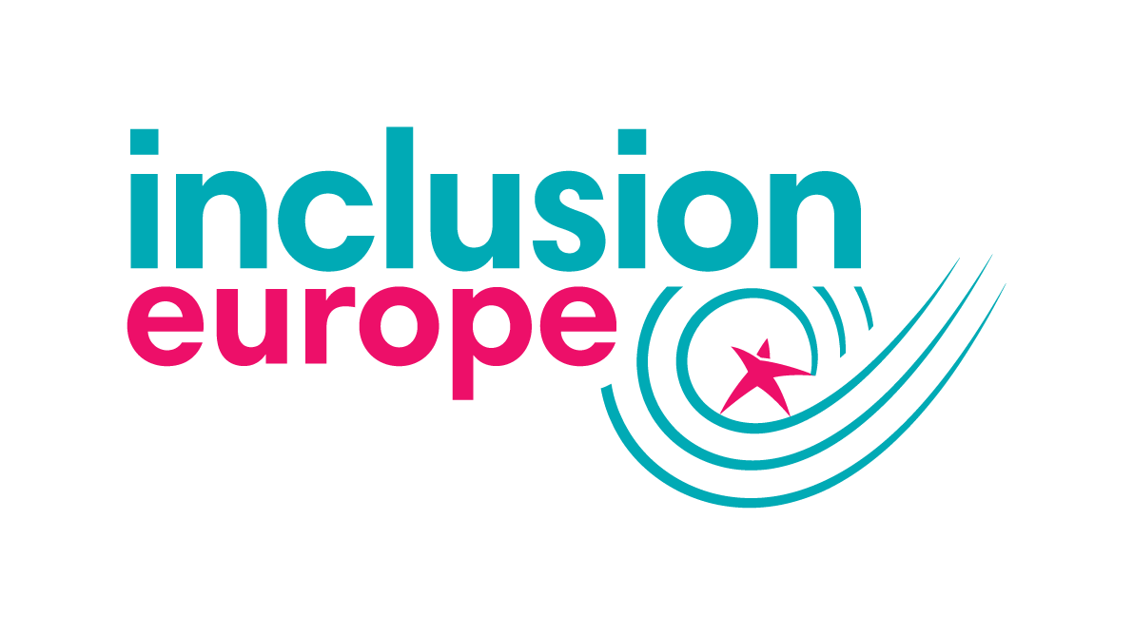

Ambitions. Rights. Belonging.

General discussion on the right of persons with disabilities to work and employment.

Inclusion Europe’s submission to the consultation
2021

Inclusion Europe is the European movement of people with intellectual disabilities and their families fighting for the equal rights and full inclusion in all aspects of life of people with intellectual disabilities, with 79 member organisations in 39 European countries.

Table of Contents
Employment in Europe 2
Interpretation of article 27 2
Deprivation of legal capacity 3
Inaccessible recruitment 3
Equal pay 3
Sheltered settings 4
Labour rights 4
Education and training 5
Public sector 5
Affirmative action 5
Accessibility and reasonable accommodation 6
Harassment 6
Relationship with other rights 7

Employment in Europe
Multiple barriers still prevent people with intellectual disabilities from benefiting of equal and fair job opportunities, despite multiple anti-discrimination legal and other instruments at EU and national levels, which try to address the situation.
Only 50.8% of persons with disabilities in the European Union are in employment, compared to 74.8% for persons without disabilities.
For people with intellectual disabilities the reality is dramatically worse:
- In Ireland only 36% of adults with intellectual disabilities were hired in some form of work, 29% in sheltered settings and 7.1% in the open labour market.
- In Scotland, only 6% of people with intellectual disabilities have a job,
- In Portugal this rate is only of 3%.
In the Netherlands, 21% and mostly in sheltered workshops; only 5% of employers report to be prepared to hire a person with a disability.
For people with intellectual disabilities who are in employment, there is a prevalence of jobs being in sheltered workshops (often not regulated under labour laws, effectively not an employment) or in temporary and low paid jobs.
This hinders their possibilities for independent living and being included in the community, due to financial dependence on relatives or on disability benefits, as well as limiting their social roles and relations.
People with intellectual disabilities’ employment prospects are being reduced from the start by the limited education they are provided, and by restrictions to legal capacity in many countries.

Interpretation of article 27

Deprivation of legal capacity
Having legal capacity is a necessity to enter into work contracts. This constitutes a major issue for people with intellectual disabilities whose right to decide has been reduced/denied based on legal capacity law.
Legal capacity is also a barrier to the creation of participation in labour unions for workers with intellectual disabilities under some form of guardianship.
The Committee should call on State Parties to fully implement article 12 of the Convention and ensure that people with intellectual disabilities can make their own decisions.

Inaccessible recruitment
Inaccessible recruitment processes constitute discriminations and prevent people with intellectual disabilities from applying for jobs in the first place.
For example, online recruitment can be discriminatory as some might need to use assistive technology.
Countries should ensure that employers provide support to candidates with intellectual disabilities through the recruitment process and promote hiring through external agencies that have expertise in accompanying and supporting candidates with intellectual disabilities, to avoid employers from using a one-size-fits-all approach.
The use of programmes targeted at people with intellectual disabilities and job carving should also be promoted and financed by countries.

Equal pay
Wage discrimination often happens to people with intellectual disabilities. It can be direct discrimination, i.e. people working in sheltered workshops are not protected by statutory measures and receive lower salaries. However, discrimination is more often indirect, as those working in the open labour market have worse working conditions and lower paid jobs, due to stigma and lack of access to higher education and vocational training.
Closely related and of crucial importance is the issue of disability benefits and employment. The so called “benefit trap”, causing people on disability benefits to not enter employment as they would lose their benefits, prevents people with disabilities from joining the workforce and increases in-work poverty.

Sheltered settings
Many people with intellectual disabilities are working in sheltered settings. Transition and full participation in the open labour market is essential. It must be based on viable alternatives for those currently in the sheltered settings and those who would potentially find a place in them.
Sheltered workshops were created as an alternative for those who have been left out of the open labour market. Having viable options of labour market participation is crucial to ensure their social inclusion and economic stability.
Inclusion Europe encourages transition to the open labour market.
The way to open labour market is especially difficult for people with intellectual disabilities due to the discrimination described above (denial of proper education, denial of legal capacity etc.).
While the transitions take place and there are still people working in sheltered settings, it is important to focus on ensuring good working conditions for them. It is crucial that people working in sheltered settings are considered workers under the law, receive equal pay and benefit of the same working conditions.
Sheltered workshops should be encouraged and accompanied to prepare and support people with intellectual disabilities to transition to the open labour market.

Labour rights
Barriers to labour rights for people with intellectual disabilities derive from these main issues:
- lack of recognition of those in sheltered settings as workers,
- lack of representation in unions,
- limitations to legal capacity.
Several countries do not consider those in sheltered settings as workers under their legal framework. Consequently, they cannot enjoy the same protection and labour rights. This means that they cannot have their own unions and cannot participate in collective bargaining. Their voices remain unheard, and they cannot advocate for better working conditions.
People with intellectual disabilities working in the open labour market, even if they are part of unions, are often underrepresented in work councils, and are not able to participate directly in collective bargaining. This lack of representation should be addressed.
Denial and limitation to legal capacity means people are unable to enter employment contracts, and to benefit from all their advantages (disposing freely with the income and other benefits, etc.).

Education and training
Proper education for all is a prerequisite for employment. Certifications from segregated education are not always equivalent to those from mainstream education, they do not always allow to pursue higher education, and in most cases, they are not valued by employers.
Even when inclusive education is provided or certifications allow to pursue higher education, opportunities are limited for people with intellectual disabilities as entry exams or grade requirements may not be adapted.
Ensuring inclusive education and accessible entry to higher education and to vocational training are essential steps to fulfil the right to employment.
Furthermore, inclusive education and vocational training should provide adequate support not only to successfully receive a diploma, but also to learn skills necessary to enter the open labour market, such as digital or social skills, writing a CV, and preparing job interviews.

Public sector
Public sector employers should lead by example both in recruitment and retainment practice for people with intellectual disabilities.
It is essential to monitor if countries comply with quotas in the public sector, and if support and specific pathways are accessible for people with intellectual disabilities. Leading by example should be a priority for the public sector.
In Spain, 2% of contracts in the public sector are reserved for people with intellectual disabilities, and 5% for people with any other disability. Furthermore, certain positions have adapted exams for people with intellectual disabilities.

Affirmative action
Affirmative action is not considered discriminatory under the European Union’s legal framework and jurisprudence, but implementation has been limited. One of the most prominent measures has been employment quotas, and even when they are implemented, people with intellectual disabilities are last in the line.
Financial incentives can be interesting for businesses to invest in diversity management, but when they do not find a suitable task for the workers with intellectual disabilities and hire them merely as a means to receive the incentive, this employment will not be sustainable.
The main focus should be to support job programmes accessible for people with intellectual disabilities and supported employment, in addition to job coaching and job carving programmes.
There is a rising interest on diversity management, mainly by large companies, but people with intellectual disabilities are still excluded, as they are considered “unemployable” by many. Their value to diversity management should be promoted, and countries should work to ensure that people with intellectual disabilities are not left behind. People with intellectual disabilities can contribute to diversity management when allowed to communicate with superiors and fulfil adequate tasks, and through their external role as an ambassador of the company. Countries should ensure small and medium enterprises receive technical assistance and financial support on hiring people with intellectual disabilities.

Accessibility and reasonable accommodation
In the European Union, reasonable accommodations at work are an obligation of the employer. However, employers still have low knowledge about providing reasonable accommodations for people with intellectual disabilities.

Harassment
People with disabilities suffer from harassment in higher rates compared to the general population. This is likely caused by a high prevalence of hate crimes and stigma leading to harassment. While the rates of harassment at work for people with disabilities are lower than for those without disabilities, this is probably tied to higher unemployment rates, and therefore the experiences of harassment at work of people with intellectual disabilities should not be underestimated. People with intellectual disabilities are particularly exposed to hate crimes and harassment, despite difficulties to report, and specific measures to protect them and training for employers on the matter should be put in place.
A key measure to fight harassment at work is making the reporting accessible. The barriers for people with intellectual disabilities to access justice (lack of legal capacity, fear of victimisation and of not being believed…) are also present when reporting harassment at work. People with intellectual disabilities should have accessible report mechanisms at their disposal and support throughout the procedure.

Relationship with other rights
Employment is a key right that is closely linked to several other rights recognised in the Convention. For people with intellectual disabilities, being a group extremely affected by exclusion and dependence, employment is the starting point for independent living and key to an effective inclusion.
Other rights are linked to employment as they are necessary for the right to employment to be fulfilled.
- inclusive education: fulfilling the right to inclusive education is necessary to get a school certificate and access higher education, acquiring valuable skills that prepare the person for the open labour market.
- independent living: having a job leads to more autonomy and financial independence. Furthermore, living in an institution can limit possibilities to work, due to stigma and exclusion. Access to community-based services can increase chances to find employment, being provided the necessary support to live autonomously.
- legal capacity: when deprived of legal capacity, in many countries it is necessary to get permission from the legal representant to sign a work contract. This is a limitation on the right to work and to choose one’s occupation. Ensuring that people with intellectual disabilities can make their own decisions is a key element for the right to employment.
- adequate standard of living and social protection: equal pay in employment is a key element to achieve an adequate standard of living for people with intellectual disabilities, as disability benefits tend to be insufficient and put the person at risk of poverty. Furthermore, lacking an adequate standard of living, for instance being homeless, can represent an obstacle to access employment. In addition, the benefit trap is highly linked to social protection.
- access to information: lack of access to information of their rights prevents people with intellectual disabilities to seek jobs or to perform well in their employment.
Furthermore, the obligation of data collection also applies to the right to employment. Particularly, data should:
- be disaggregated by type of disability, to inform policies that target specific groups such as people with intellectual disabilities.
- include people living in institutions and in sheltered settings.
- display the gender and disability gap.
- illustrate barriers to employment, such as inaccessibility, lack of reasonable accommodations, or lack of qualification.
Inclusion Europe believes that the right to employment is essential for people with intellectual disabilities, and that emphasis should be put on accessibility, reasonable accommodations, legal capacity, and equal pay and conditions. The Committee must encourage State Parties to work towards achieving higher employment rates of people with intellectual disabilities, financing support programmes and providing reserved contracts and other incentives.

Council Directive 2000/78/EC of 27 November 2000 establishing a general framework for equal treatment in employment and occupation, https://eur-lex.europa.eu/legal-content/EN/TXT/HTML/?uri=CELEX:32000L0078&from=FR
According to EU SILC 2017. Data analysed by the Academic Network of European Disability Experts (ANED). See also European Disability Forum. Employment. Available at: http://www.edf-feph.org/employment
National Disability Authority (NDA) ‘Disability and Work: the Picture We Learn From Official Statistics’ (Dublin: NDA, 2005) p 21. Available at: http://nda.ie/nda-files/Disability-and-Work-The-picture-we-learn-from-official-statistics.pdf
ENABLE Scotland, Brussels, 2019.
Fenacerci in 2021 according to a census from 2001
Inzicht in inclusie II, National Human Rights Insitute, 2018, cited in DPO Shadow Report UNCRPD, https://iederin.nl/wp-content/uploads/2019/12/Schaduwrapport-VN-verdrag-Handicap.pdf
Disability inequality and the recruitment process: responding to legal and technological developments - Frederike Scholz, The University of Leeds, Leeds University Business School - l© 2017 The University of Leeds and Frederike Scholz
Antwerp Management School, European research and the lessons learnt, 2020, https://www.inclusion-europe.eu/wp-content/uploads/2015/03/D-3.1-The-European-research-and-the-lessons-learnt-as-uploaded-in-the-participant-portal-1.pdf
Briefing on minimum income and social protection www.inclusion-europe.eu/wp-content/uploads/2015/03/Briefing-on-minimum-income-and-social-protection.docx
See for instance the decision of the Court of Justice of the European Union, Hellmut Marschall v Land Nordrhein-Westfalen, 1997, https://eur-lex.europa.eu/legal-content/EN/TXT/?uri=CELEX%3A61995CJ0409
Some successful examples in Europe: KLAPjob, Rytmus, Ability@Work
Antwerp Management School, European research and the lessons learnt, 2020, https://www.inclusion-europe.eu/wp-content/uploads/2015/03/D-3.1-The-European-research-and-the-lessons-learnt-as-uploaded-in-the-participant-portal-1.pdf
Council Directive 2000/78/EC of 27 November 2000 establishing a general framework for equal treatment in employment and occupation, https://eur-lex.europa.eu/legal-content/EN/TXT/HTML/?uri=CELEX:32000L0078&from=FR
Antwerp Management School, European research and the lessons learnt, 2020, https://www.inclusion-europe.eu/wp-content/uploads/2015/03/D-3.1-The-European-research-and-the-lessons-learnt-as-uploaded-in-the-participant-portal-1.pdf
FRA, Fundamental Rights’ Survey, 2021, https://fra.europa.eu/en/data-and-maps/2021/frs?mdq1=dataset
FRA, Fundamental Rights’ Survey, 2021, https://fra.europa.eu/en/data-and-maps/2021/frs?mdq1=dataset
Macdonald, ‘Community fear and harassment’: learning difficulties and hate crime incidents in the north-east of England, 2015.

