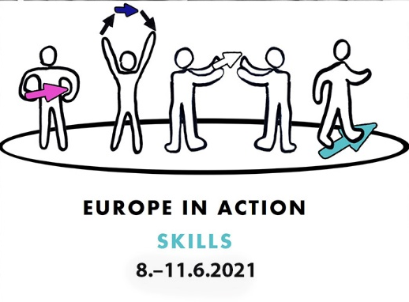

Skills
How to put to work the skills people with intellectual disabilities have.
Jobs and support for employment.
Person-centred support for inclusion.

Europe in Action conference
8 – 11 June 2021
online from Tampere, Finland

Europe in Action conferences bring together more than 200 people with intellectual disabilities, their families, activists and professionals.
They discuss issues important to them and share experiences and ideas to advance inclusion.

Europe in Action conferences are organized every year by Inclusion Europe and a national partner organisation (Inclusion Europe member).
The first Europe in Action conference was organised in 2003.
You can revisit all the previous conferences here.

In 2021 the conference is organised by Inclusion Finland KVTL (Tukiliitto) and Inclusion Europe.
The conference is brought to you from Tampere, Finland, and you can participate from anywhere online.

Inclusion Finland KVTL (Tukiliitto) is a nationwide human rights and non-governmental organization defending the rights of people with intellectual disabilities and their loved ones.
Tukiliitto promotes inclusion and equality. The foundation of its work lies in the UN Convention on the Rights of Persons with Disabilities.
In 2021 Inclusion Finland KVTL (Tukiliitto) celebrate its 60th anniversary.
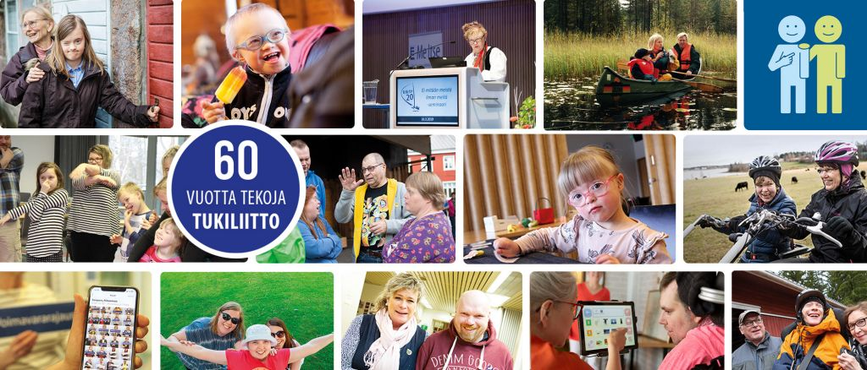
About the conference
The conference is an opportunity to hear about examples and knowledge of the topic, latest trends and innovations in support for employment and inclusion.
Jyrki Pinomaa, president of Inclusion Europe

Timetable
All times are Finland (EEST). Find your local time.
Tuesday 8 June 11:00 – 15:00
Wednesday 9 June 10:00 – 16:30
Thursday 10 June 10:00 – 16:30
Friday 11 June 10:00 – 12:30

Languages
The conference will be interpreted between English and Finnish.
Some sessions will be only in English or only in Finnish.

Registration
Register here to attend the conference.
Registered participants can view recordings of plenary sessions.

Social media
Hashtag: #EuropeInAction21
Accounts: @InclusionEurope and @Tukiliitto
Tuesday 8 June
10:30 | Online platform opens for connection.
11:00 | Opening
Risto Burman, director Inclusion Finland KVTL
Krista Kiuru, minister of family affairs and social services of Finland
Music, Vimmart - Inclusive Art School
Interpretation between Finnish and English.
11:20 | Having a job: a way to inclusion
László Bercse, vice-president Inclusion Europe; chair European Platform of Self-Advocates; co-chair EFOESZ, Hungary
Interpretation between Finnish and English.
12:00 | Employment as a human right
Hisayo Katsui
associate professor of disability research, University of Helsinki
Interpretation between Finnish and English.

13:00 | Break
14:00 | How to make a difference: Self-advocacy in Finland and Europe
Inclusion Finland network of self-advocates shares experiences and examples of making an impact and influencing things.
A group on self-advocates and experts by experience come together to share their experiences about how they have made a difference: in their lives, in their community or in society. We welcome people from all over Europe to come to discuss and share their own experiences in this workshop.
Interpretation between Finnish and English. Duration 90 minutes.
14:00 | Job coaching: How to support employers to enable good jobs for people with intellectual disabilities
Katri Hänninen, development manager, Employers Service Foundation for People with an Intellectual Disability (KVPS)
Simo Klem, expert of employment, FAIDD
Minna Korpela, Job coach, Employers Service Foundation for People with an Intellectual Disability (KVPS)
Kirsi Konola, CEO, Employers Service Foundation for People with an Intellectual Disability (KVPS)
Ilkka Rantanen, expert, TE services
This session, organized by Service Foundation for People with an Intellectual Disability (KVPS) of Finland will focus on how to best support employers job coaching enable meaningful jobs people intellectual disabilities.
English
14:00 | Visiting a place of work
Stefano Onnis, Museo Come un Albero, Italy
English
15:00 | End of day 1

Wednesday 9 June
9:30 | Online platform opens for connection.
10:00 | A meaningful life
Frank Martela, philosopher and researcher, Aalto University
Interpretation between Finnish and English.
11:00 | Break
11:30 | Developing services to support inclusion
Pirjo Valtonen and Kari Vuorenpää, KVANK Committee on Work and Day services
Pirjo and Kari talk about using quality criteria of inclusion and employment as a tool to develop support services.
Interpretation between English and Finnish
12:30 | Break
14:00 | Precise work ability, employer cooperation and customized work tasks
Kari-Pekka Martimo, Ilmarinen insurance company,
Pia Vaajakallio, Vamlas foundation,
Ville Grönberg, Finnish Institute for health and welfare
Discussion about cooperation with employers: What does “partial work ability” tell the employer about the job seeker? What about “precise work ability”? How can be work tasks customized?
English
14:00 | Job first: employment for inclusion
Zuzana Thürlová, Jurta, Czechia
English
14:00 | Pertti’s Choice Workshop  Sami Helle and Kalevi Helvetti, founders of Pertti’s Choice, Finland  Pertti’s Choice presents Finnish outsider art and musical performances, including a private view to Kalevi’s Virtual Gallery. Pertti’s Choice is an Outsider Art agency, shop & Gallery and the first social enterprise founded by people with learning disabilities. The founding members are also known for punk band Pertti Kurikan nimipäivät.  English
14:00 | Kognitiivisen saavutettavuuden edistäjät Selkeästi meille -hankkeessa: palkkatyötä ja kansalaisvaikuttamista
(Promoters of cognitive accessibility in the Clearly for Us project: paid work and civic engagement)
Heikki Oksanen, Roberto Polsa, Satu Timperi, Mira Vihmo, Mikko Apell, Kehitysvammatuki 57, Finland
Finnish
15:00 | break
15:30 | Public service employment for people with intellectual disabilities
Keenan Wellar and Julie Kingstone, LiveWorkPlay, Canada
Silvia Muñoz, Project Manager at Plena inclusión, Spain
Interpretation between English and Finnish
15:30 | Day services in supporting the agency and inclusion of a person in need of wide-ranging support: “Movement to My Day and Support to My Choices”
In the workshop, you will hear about the Inclusion Finland’s and its Malike unit’s activity “Movement to My Day, Support for My Choices”, which aims to promote the development of day time services to support inclusion.
Johanna Sakko and Mari Hakola, Inclusion Finland KVTL, Finland
English

16:30 | End of day 2

Thursday 10 June
9:30 | Online platform opens for connection.
10:00 | CRPD round table: Sheltered workshops – what purpose and future?
Fatma Wangare Haji, KAIH, Kenya
Kimber Bialik, Inclusion International
Moderated by Helen Portal, Inclusion Europe
Interpretation between Finnish and English.
11:00 | Break
11:30 | Enable Works
Richard Hamer, Enable Scotland, United Kingdom
English
11:30 | When a skill meets a task: the story of an employee
Anna Valkama, expert by experience and Anne Vuorenpää planner, Inclusion Finland KVTL
Elisa Nappa, planner at Service Foundation for People with an Intellectual Disability (KVPS)

In this workshop, you will hear an example of how a task found its doer. One example of employment path is described from their own perspectives by the employee, the job coach and the support colleague. Its duration is 90 minutes.
Interpretation between English and Finnish. Duration 90 minutes.

11:30 | Osuuskunnat ansiotyön mahdollistajana
(Skills for money: Cooperatives as an enabler of gainful employment)
Kari Vuorenpää, working life expert, Inclusion Finland KVTL,
Valtteri Rantanen, chair of the board, Omillaan cooperative
Jyrki Vihriälä, project manager, JAMK University of Applied Sciences
Finnish
11:30 | Ajankohtaista työllistämisen edistämisessä
(What’s going on in promoting employment)
Patrik Tötterman, specialist, Ministry of Economic Affairs and Employment of Finland
Aki Tetri, project manager, Finnish Institute for Health and Welfare
Pirjo Sjölund, head of unit, City of Vantaa
Mika Piiroinen and Ulla Peippo, Työtä-project, South Karelia Social and Health Care District (Eksote)
Finnish
12:30 | Break
14:00 | Building a diverse working environment: case L&T
Jorma Mikkonen, director of corporate relations and responsibility, Lassila & Tikanoja (SVP Public Affairs and Sustainability)
Interpretation between Finnish and English.
15:00 | Break
15:30 | Customised Employment: The role of Self-Determination and Person-Centered Services
Renáta Tichá, research associate
Brian Abery, research manager; both Institute on Community Integration, University of Minnesota, USA
Interpretation between English and Finnish
15:30 | Beautiful difference: art and dance session
Allie Walton-Robson & Headway Arts, United Kingdom
English
15:30 | KLAPjob
Claus Bergman Hansen, leader of KLAPjob
Klaus Marqvertsen, KLAPjob ambassador, both LEV, Denmark
English
15:30 | VVV-areena – tukea ryhmien ja yksilöiden sähköisten vuorovaikutustaitojen harjoitteluun  (VVV-arena - support for the training of groups and individuals in electronic interaction)  Veijo Nikkanen and the VVV-group, Inclusion Finland KVTL  Finnish
16:30 | End of day 3

Friday 11 June
9:30 | Online platform opens for connection.
10:00 | How EU supports employment of people with disabilities
Lucie Davoine, European Commission
in interview led by Soufiane El Amrani, Inclusion Europe
English
10:00 | Teatterista voimaa vuorovaikutukseen
(Theatre as a force for interaction)
Petri Mäkipää, Anne Vuorenpää and the theatre group, Inclusion Finland KVTL
Finnish
10:00 | Talking employment: Online goalsetting
Melanie Shametaj, project manager, and Erika Backman, project coordinator, Steget vidare -project, Inclusion Finland FDUV
During the pandemic, when it was impossible to facilitate face-to-face groups, Inclusion Finland/FDUV started to organize online-courses on employment issues.
English
11:00 | Break
11:10 | Skills and work of the future
Perttu Pölönen, writer, futurist
Interpretation between Finnish and English.
12:00 | Closing the conference
Jyrki Pinomaa, president, Inclusion Europe
Petri Liukkonen, president, Inclusion Finland KVTL
Me Itse ry, The Finnish Self-Advocacy Society of Persons with Learning Disabilities.
Music, Vimmart - Inclusive Art School
Interpretation between English and Finnish
12:30 | End of the conference

This is not the final version of the program.
The program and speakers can change.

Speakers
László Bercse, Hungary
László is vice-president of Inclusion Europe and a chair of the European Platform of Self-advocates.
He is co-chair of the Hungarian organisation ÉFOÉSZ and has been a long-standing activist for the right to vote and accessibility in all aspects of the elections process.
László will talk about the importance of employment for inclusion of people with intellectual disabilities.

Lucie Davoine, European Commission
Lucie is deputy head of Disability and Inclusion Unit at the Directorate-General for Employment, Social Affairs and Inclusion, European Commission.
Lucie will talk about how the EU supports employment of people with disabilities. Especially with the EU Disability Strategy, the Social Pillar and the European Commission’s anti-discrimination campaign.

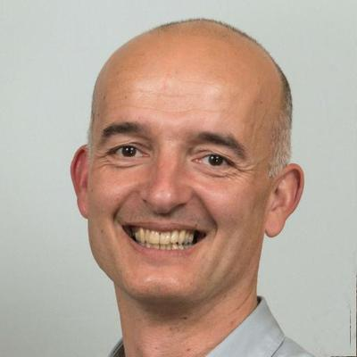
Richard Hamer, United Kingdom
Richard is director of ENABLEWorks, an employment support programme of ENABLE Scotland.
Richard will talk about how ENABLE Scotland support employment of people with intellectual disabilities with their ENABLEWorks and Breaking Barriers programmes.

Hisayo Katsui, Finland
Hisayo Katsui is an Associate Professor in Disability Studies, at the Faculty of Social Sciences, University of Helsinki.
Katsui’s subject in the conference is Employment of people with disabilities as a human right.
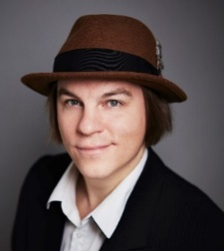
Frank Martela, Finland
Frank is a philosopher, a docent of well-being psychology and an internationally recognized researcher of intrinsic motivation, well-being and relevance. He is a popular and energetic speaker who is considered in Finland as one of the leading experts in questions of more internally motivated, self-directed and meaningful life.

Jorma Mikkonen, Finland
Jorma Mikkonen is a Director of Corporate Relations and Responsibility, at Lassila & Tikanoja (SVP Public Affairs and Sustainability). Lassila & Tikanoja is a service company of circular economy. With operations in Finland and Sweden, L&T employs 8,100 people.
Jorma’s topic at the conference is building a diverse working life, case Lassila & Tikanoja.

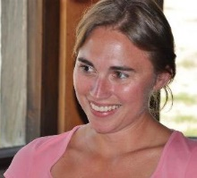
Silvia Muñoz, Spain
Silvia is project manager at Plena inclusión, where she has worked on inclusive employment, volunteering and other topics.
Silvia will present Plena inclusion’s programmes supporting employment of people with intellectual disabilities in Spanish public services.

Keenan Wellar and Julie Kingstone, Canada
Keenan and Julie are co-leaders of LiveWorkPlay. The organization provides direct supports and services in the Ottawa area, Canada, to help the community welcome and include people with intellectual disabilities, autistic persons, and individuals with a dual diagnosis to live, work, and play as valued citizens.
Keenan and Julie will talk about their recent report on making employment within the Public Service of Canada accessible and successful for people with intellectual disabilities.
Perttu Pölönen, Finland
Perttu is a futurist, inventor and author.
Perttu talks about the challenges and the possibilities regarding future of work, information technologies, education, disruption and ethics.

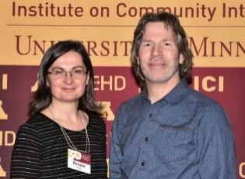
Renáta Tichá and Brian Abery, United States
Renáta and Brian both work at the Institute on Community Integration, University of Minnesota.
Renáta has extensive experience in development, implementation and conducting research with individuals with intellectual and developmental disabilities.
Brian is co-director of the Research and Training Center on HCBS Outcome Measurement, and a principal investigator on grants related the enhancement of the life quality of children, youth and adults with disabilities.
Renáta and Brian will talk about the role of self-determination and person-centered approaches in facilitating positive outcomes in customised and supported employment among people with intellectual disabilities.

Claus Bergman Hansen and Klaus Marqvertsen, Denmark
Claus Bergman Hansen is leader of KLAPjob. KLAPjob has years of experience working with supported employment to promote inclusion of people with disabilities in the labour market. KLAPjob is organised by the danish organisation Lev.
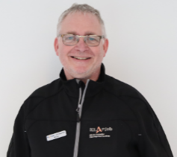
Klaus Marqvertsen is a KLAPjob-ambassador. He found his employment through the KLAPjob project, and he is currently employed at a car repair shop called Skorstensgaard, in Denmark.
Claus and Klaus are going to talk about how KLAPjob works and how it was the job-matching process for Klaus to find his employment.

Zuzana Thürlová, Czechia
Zuzana is director of social services at Jurta, a Czech organization supporting people with disabilities.
Zuzana will take us on a virtual visit to supported employment, and how it is used to include people into society; also those leaving institutions.

CRPD round table speakers
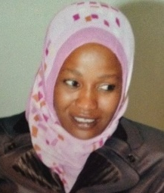
Fatma Wangare Haji, Kenya
Fatma is executive officer of KAIH.

Kimber Bialik
Kimber is a project manager at Inclusion International
Follow us for updates:

@InclusionEurope

facebook.com/inclusioneurope

youtube.com/user/inclusioneurope

Inclusion Europe
Avenue des arts 3, 1210 Brussels, Belgium
+32 25 02 28 15
secretariat@inclusion-europe.org
www.inclusion-europe.eu

Co-funded by the European Union.

