Conference program

Europe in Action
to End Segregation

7 – 9 September 2022 in Brussels
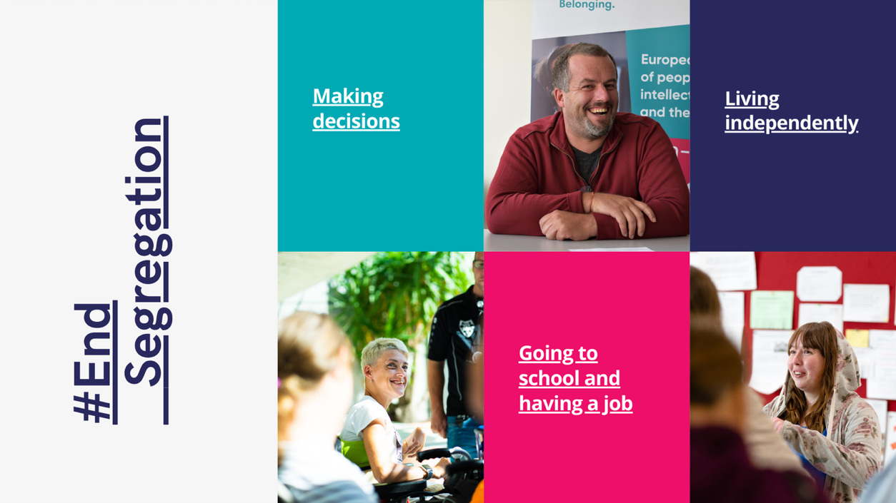

Europe in Action conferences are great
for getting new ideas,
sharing good practices,
connecting with people.
Jyrki Pinomaa, president of Inclusion Europe

Table of contents
About Europe in Action conferences 3
Europe in Action 2022 4
Dates, times, locations 5
Getting around 8
Registration 10
Agenda day 1: Wednesday 7 September 11
Agenda day 2: Thursday 8 September 17
Agenda day 3: Friday 9 September 21
Accommodation 22

About Europe in Action conferences
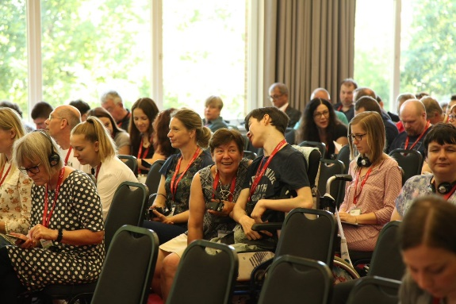
Europe in Action conferences bring together more than 200 people with intellectual disabilities, their families, activists, and professionals.
Participants discuss issues important to them and share experiences and ideas to advance inclusion.

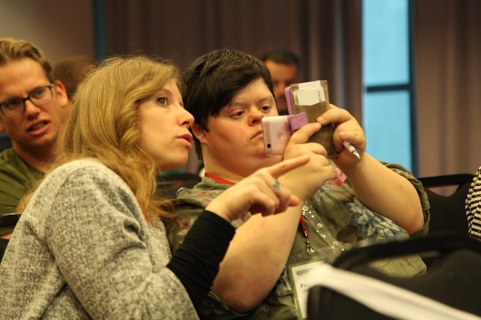
Europe in Action conferences are organized every year.
The first Europe in Action conference was organised in 2003.
You can revisit all the previous conferences here.

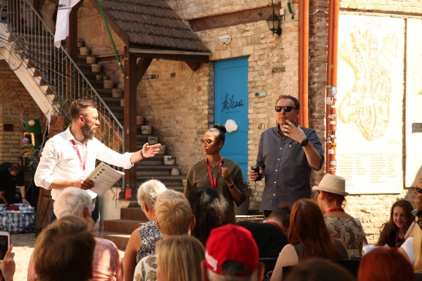
Europe in Action conferences connect people, organisations, ideas, and places.

Europe in Action 2022
The conference program flows in 2 streams:
- Open sessions
These sessions have speaker and presentations about a topic.
There is room to ask questions and talk about the topic.
Everyone is invited to come.
These sessions are an opportunity to learn about a topic,
and to meet people and organisations.
- Conversations for our future
These workshops are for Inclusion Europe members.
There is space to have good, deep discussions about topics that matter to us.
It is an opportunity to share with other members the good work
everyone is doing, and to learn from it.

Some of these workshops are based on a paper to discuss:
We will send this paper in advance before the conference.

Some other workshops are based on the work our members are doing:
Please bring examples of your programs or projects you would like to share with others!

Session overview: Dates, times, locations
Wednesday, 7 September
10:00 – 12:15 | Opening session  Ending segregation  Support in Ukraine | Rue de la Loi 75,  Thon Hotel EU
12:15 – 13:30 | Lunch | Thon Hotel EU
14:00 – 16:30 | Deinstitutionalisation in Czechia | Thon Hotel EU
14:30 – 16:45 | Jobs for people  with intellectual disabilities | Rue Belliard 99,  EESC – room JDE63
14:30 – 16:00 | Practising personal future planning to realise big dreams  Workshop with José Smits | Avenue des arts 3,  Inclusion Europe

Thursday, 8 September
9:30 – 11:00 | Conversations for our future  4 parallel workshops. | Avenue des arts 7-8, Mundo Madou
11:00 – 11:30 | Break
11:30 – 12:30 | Conversations for our future  4 workshops continue from morning. | Mundo Madou
12:30 – 14:00 | Lunch | Mundo Madou
14:00 – 15:30 | Members exchange  Please bring examples of programs or projects you would like to share! | Mundo Madou
14:30 – 16:00 | Disability-inclusive rebuilding  in Ukraine | Avenue des arts 6-9 Welkin
18:30 - 20:00 | Dinner | Mundo Madou
Friday, 9 September
9:30 – 11:00 | Conversations for our future  What we learned,  and what we’ll be doing together. | Rue de la loi 42  L42
11:00 – 11:30 | Break
11:30 – 12:30 | Closing session | L42

Language:
The conference is in English.
Deinstitutionalisation in Czechia session is interpreted in Czech and English.
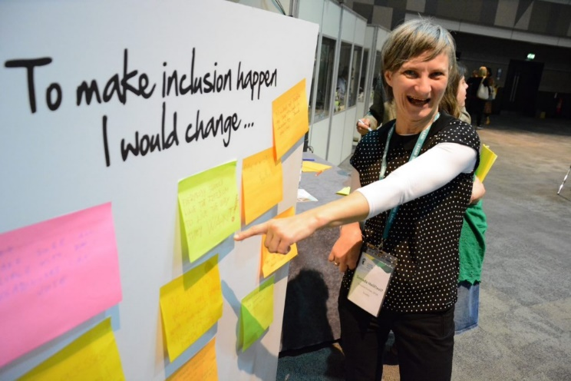

Getting around
The conference sessions take place in various locations in Brussels.
These locations are in a walking distance in the European Quarter.
We hope this will give you a good opportunity to see a bit of Brussels too!
Here is how to get to each place:

Day 1, Wednesday
Rue de la loi 75, Thon Hotel EU (opening session)
- Arts / Loi metro station for lines 2 and 6
- Maelbeek metro station for lines 1 and 5

Rue Belliard 99, EESC – European Economic and Social Committee (session on jobs)
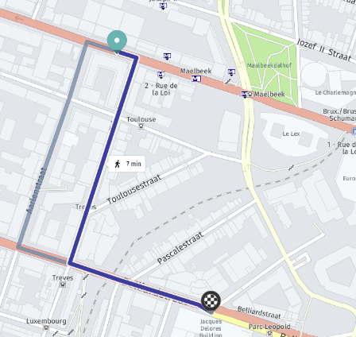
- From Thon Hotel walk via Treves street,
turn to Belliard.
- It takes about 10 minutes.

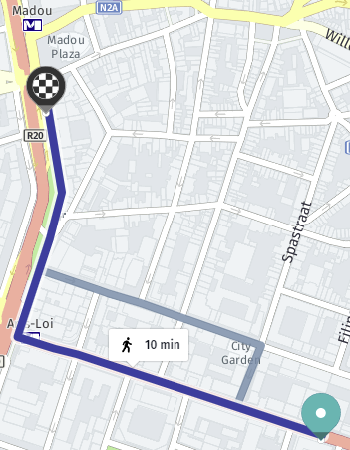
Avenue des arts 3 – Inclusion Europe
- From Thon Hotel, walk up Rue de la loi,
turn right to Avenue des arts.
- It takes about 10 minutes.

Day 2, Thursday
Avenue des arts 7-8, Mundo Madou
- Arts / Loi metro station for lines 1 and 5, or 2 and 6
- Madou metro station for lines 2 and 6

Day 3, Friday
Rue de la loi 42, L42
- Arts / Loi metro station for lines 1 and 5, or 2 and 6

Registration
There is no participation fee for the conference.

Registration for all 3 days of the conference for Inclusion Europe members:
- Please click here to register and attend the whole conference.

There is specific registration for open sessions where everyone is invited:
- If you register for all 3 days (above), you don’t need to register again below.
7 September:
- The practice of ending segregation; Support to Ukraine – register for opening session of the conference
- Deinstitutionalisation in Czechia – register now
- Jobs for people with intellectual disabilities – register now
8 September:
- Disability-inclusive rebuilding in Ukraine – register now

Questions?
Contact Inge Volleberg: i.volleberg@inclusion-europe.org

Agenda day 1: Wednesday 7 September
9:00 Registration of participants at Rue de la loi 75, Thon Hotel EU

Open session 1: Ending segregation; Support to Ukraine
10:00 - 12:15 at Rue de la loi 75, Thon Hotel EU

Jyrki Pinomaa, president of Inclusion Europe
- Jyrki talks about what ending segregation means for him,
and for his 2 sons with disabilities.
- Jyrki also talks about Inclusion Europe’s work to end segregation.

Elisabeta Moldovan, self-advocate and activist, Ceva de spus / Unloc, Romania
- Elisabeta talks about her experience leaving institutions after many years.
- And about how she now works to help other people get out of institutions and have a life in the community.
Cinzia Agoni, president of GAMP, Belgium
- Cinzia talks about support for people with complex support needs.

Katarina Ivanković Knežević, director for Social Rights and Inclusion at the directorate general for employment, social affairs and inclusion of the European Commission

Raisa Kravchenko and Olena Kravchenko, VGO Coalition, Ukraine
- Raisa and Olena talk about the situation of people with intellectual disabilities and their families during the Russian war on Ukraine.
- And about the needs in the close future:
What needs to be done to improve disability-related support in the country to prevent people ending up in “care” institutions.

Information about the session, and registration

12:15 – 13:30 Lunch at Thon Hotel EU

Open session 2: Deinstitutionalisation
in Czechia
14:00 - 16:30 at Thon Hotel EU

The event presents deinstitutionalisation at national, regional, and local levels.
- Zdislava Odstrčilová, deputy minister, Ministry of Labour and Social Affairs
- Jaroslava Filipová, director, Domov na rozcestí Svitavy
How the institutions was closed down,
and how the new services work.
- Self-advocate with experience moving from an institution into community (details to be confirmed), Sebeobhájci Uherské Hradiště
- Milena Johnová, councillor for health and social affairs, City of Prague
About recent closer of an institution, developing community-based services.

European Commission presents how the EU supports deinstitutionalisation:
- planned Guidance to Member States: Independent living and inclusion
- European Social Fund support for deinstitutionalisation
- European Regional and Development Funds support for inclusion and community-based services
Jan Pfeiffer on EU funding in practice: What has been done, and remains to be done in Czech mental health care reform.
- Jan Pfeiffer has been a long-standing deinstitutionalisation advocate;
- currently, Jan works at ministry of health leading the mental health care reforms

László Bercse with reflections on deinstitutionalisation in Czechia.
- László Bercse is vice-president of Inclusion Europe,
and chair of the European Platform of Self-Advocates

Information about the session, and registration

This session is organised in collaboration with the European Commission.

Open session 3: Jobs for people
with intellectual disabilities
14:30 - 16:45 at Rue Belliard 99 – EESC, room JDE63

Soufiane El Amrani, self-advocacy and easy-to-read officer, Inclusion Europe
Ana Martinez, self-advocate, Plena Inclusion:
- Experience of work in public administration in Spain

Pietro Vittorio Barbieri, EESC, President of Thematic study group disability rights
- Improving the rights of people with disabilities

Gillian Maguire and Brian Collins, Microsoft
- Microsoft’s Supported Employment Program
Information about the session, and registration

This session is organised with the European Economic and Social Committee (EESC).

Practicing personal future planning
to realise big dreams
14:30 - 16:00 at Avenue des arts 3 – Inclusion Europe

Workshop with José Smits, Inclusie Nederland

Every person wants to build an independent life and to be included.
For persons with a disability, it might seem a dream that can never come true.
Families might despair: How to provide necessary protection for your loved one with a disability? How to find a suitable home, how to get enough finances?
How to build necessary friendships?
We invite persons with a disability and/or their family to talk about their dream. And how to come up with a concrete plan to realise at least part of this dream.
We ask persons with a disability or family member about their dream.
Participants contribute about what steps can be taken.
It is a hands-on workshop practicing this technique of personal future planning.
Every participant gets a feel of the instrument such that sessions can be organised at home in future occasions.

Agenda day 2: Thursday 8 September

Conversations for our future
9:30 - 12:30 at Avenue des arts 7-8 – Mundo Madou

4 parallel workshops to learn from one another,
and to improve how we work together for inclusion.

- What deinstitutionalisation means for Inclusion Europe.
Discussion on a new position paper.
Milan Sverepa leads a conversation about key questions on the topic,
and what Inclusion Europe members think and do about it.

- Legal capacity: Lessons and tools to implement change
Camille Latimier, director of Inclusion Czechia, leads a workshop about systemic steps to restore the right to decide for people with intellectual disabilities.

- Self-advocacy organising.
The European Platform of Self-Advocates workshop about self-advocacy at European and national levels.
László Bercse with EPSA activities and how they can be more inclusive.
  - What can be done to include people with more support needs in EPSA activities?
Ana Martínez presents national platform of self-advocates in Spain.
  - How was it set-up?
  - What can other countries learn from it to organise self-advocacy movement?

- How should social protection policies support families
of people with intellectual disabilities?
Kimber Bialik, Inclusion International, and Helen Portal lead workshop about the role of families in supporting people with intellectual disabilities.
  - What are the problems in how families are treated in social protection?
  - What should be done about it?

12:30 – 14:00 Lunch at Mundo Madou

Open session 3: Disability-inclusive rebuilding in Ukraine
14:30 - 16:00 at Avenue des arts 6-9 – Welkin

Catherine Naughton, director, European Disability Forum
Raisa Kravchenko, VGO Coalition, Ukraine
- Reconstruction needs in Ukraine
Freek Spinnewijn, director, FEANTSA
- Housing and policies to prevent homelessness
European Disability Forum
- Accessible environments and building
European Commission, Joint Research Centre, New European Bauhaus:
- New European Bauhaus support to disability-inclusive design and environment

Information about the session, and registration

Members exchange
14:00 - 15:30 at Mundo Madou

Marketplace of projects and developments in different countries.
Please bring examples of programs or projects you would like to share!
We want to hear about your good work:
- Which programs or activities you want to share with others?

You can tell others about what needs to be done in your country.
- In which areas would you need more support, to get examples from others?

Presentation of a new program “National inclusion indicators” to ask your feedback.
- The program measures and shows the level of inclusion in each country.
- Over the years it will provide evidence about situation in Europe.

18:30 – 20:00 Dinner at Mundo Madou
Opportunity to meet and eat.

Agenda day 3: Friday 9 September
9:30 - 12:30 at Rue de la Loi 42 – L42

Conversations for our future
What we learned from our conversations.
What are next steps and actions we’ll take together for inclusion.

Sylvia Costantini, managing director, Philanthropy and Fundraising Europe
- Sylvia talks about current trends in fundraising, how organisations need to approach getting money to support their core activities.

Closing session

Paul Alford, Inclusion Ireland self-advocate
- Paul speaks about his journey out of institutions after 32 years spent there.
- He shares how he got support to buy his own place, hire his person of support, and learn how to live (again) in the community.
Final words from Inclusion Europe leadership.

Accommodation

Please book your own accommodation.

Below are some suggestions near the locations of the conference.
When booking your accommodation,
look for options near Place Madou, or European Quarter in Brussels.

Hotel | Link | Comments
Motel One Brussels | http://www.booking.com/Share-dmuA5j | Wheelchair accessible
B-apart hotel regent | http://www.booking.com/Share-zgVXHS
Best Western Hotel Royal Centre | http://www.booking.com/Share-WN0tCa
Hotel du Congrès | http://www.booking.com/Share-3vjEKV
Institute of Cultural Affairs | http://www.booking.com/Share-3CXi3e | Bed & breakfast
Courtyard Marriott Brussels EU | http://www.booking.com/Share-95Gf0y | Wheelchair accessible
Thon Hotel EU | https://www.thonhotels.com/fr/hotels/belgique/bruxelles/thon-hotel-eu/ | Wheelchair accessible

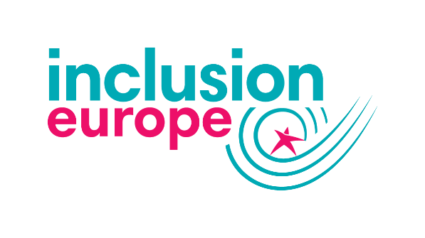

Ambitions. Rights. Belonging.

20 million people with intellectual disabilities and their families from 39 countries.


Funded by the European Union. Views and opinions expressed are however those of the authors only and do not necessarily reflect those of the European Union or the European Commission. Neither the European Union nor the granting authority can be held responsible for them.

