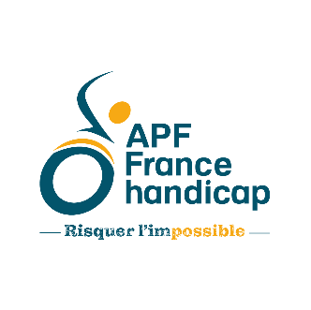

Press Release

Confidentiel et sous embargo jusqu’au dimanche 16 avril à 23H59
Parutions possibles le 17 avril à 0H01

The Council of Europe denounces the violation of the rights of people with disabilities by the French State

Following the collective complaint filed in 2018
to the Council of Europe's Committee on Social Rights
by Unapei, APF France handicap, Unafam and FNATH,

France’s violation of the rights of persons with disabilities is established.
Lack of support and shortage of support services, socio-economic injustices, difficulty in accessing housing and health care, but also the refusal of schooling... The freedom and dignity of people with disabilities are hindered, their rights are violated by the French state. The Council of Europe has now declared this.
This finding is the result of a collective complaint launched by Unapei, APF France handicap, Unafam and FNATH regarding the failure of the French State to respect its obligations towards people with disabilities and their families.
The NGOs welcome this decision and hope that it will not remain yet another forgotten report about disability policies. They underline the urgent need to reform our country's disability policy in its whole,and demand immediate measures. In 2023, the fact that people with disabilities still experience these injustices daily is intolerable.

"We are proud to see that our work is finally coming to fruition! It is a recognition of our actions and of our determination to change things. However, we cannot be fully satisfied, because it is a recognition of the violation of the rights of people with disabilities, and an affirmation of the failure of the French State to ensure that people with disabilities and their families enjoy a dignified life where they can make their own choices. There remains work for the French government so that people with disabilities - whether physical, motor, intellectual or psychological – can at last benefit from the same rights as other citizens." From the presidents of the four NGOs that lodged the complaint .

The findings of the Council of Europe's Social Rights Committee

The Council of Europe's Committee of Social Rights thus recognised the violation by the French State of its obligations towards people with disabilities and their families (international obligations and its own responsibilities) in a decision handed down in December 2022 after months of examination and unveiled today.
The Council of Europe shows that in all areas of life, people with disabilities are hindered in the exercise of their rights.  It confirms that these obstacles have negative consequences on the lives of families, who compensate for the shortcomings to the detriment of their physical, psychological, economic, professional and social balance.  The lack of access to adequate support services, public services and transport, schooling, housing and health care, as well as the lack of sufficient resources to live in dignity, hinders on a daily basis the possibility for people with disabilities to live autonomously and by choice, like other citizens.  The decision also shows the failure of the state to guarantee people with disabilities and their families the effective protection against discrimination –in school, to access health care, housing or in their everyday life.  With this decision, the Committee also recalls what is expected of the French State to guarantee the effectiveness of the rights set out in the European Social Charter. | 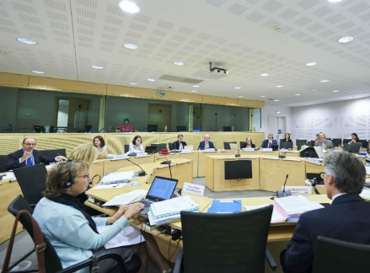

"Reinforced by the Council of Europe's decision, we will continue our actions and will not hesitate to put pressure on political decision-makers, both during the National Disability Conference, but also at the highest level of the State and with local elected representatives and members of parliament. We are more determined than ever to build a truly inclusive society that respects the rights of everyone, without exception. There is a lot of work to be done, but together, it is possible. Presidents of Unapei, APF France Handicap, Unafam and FNATH.

The NGOs have denounced this. Today, they are calling for rapid and concrete changes in 6 key areas

In order for people with disabilities to live with dignity, whatever their disability and socio-economic situation, Unapei, APF France handicap, Unafam and FNATH are now demanding that the recommendations made be translated without delay into coherent, coordinated and costed public policies, so that the rights of people with disabilities are finally respected.

In terms of support
The Council of Europe confirms that the French authorities have not put in place support adapted to the needs and expectations of all people with disabilities. Too many people are still without adapted solutions.
The NGOs are calling for reliable figures and data to identify and quantify needs and to develop action plans to meet them.

In the area of resources and compensation
The Council of Europe confirms that the standard of living of people with disabilities and their families is lower on average than that of the rest of the population, which constitutes a profound socio-economic injustice.
The NGOs are calling for measures to increase the standard of living of people with disabilities, who are particularly affected by inflation. They demand the financial revaluation of allowances, benefits and compensations to enable them to live a dignified, chosen, autonomous and included life in society, without any break in their path.

In terms of accessibility
The Council of Europe confirms that the principle of accessibility, provided for in the law since 1975 and 2005, is still not respected. Worse, the obligations of the State and its services in terms of accessibility have regressed in all areas and the new regulations postpone indefinitely the real implementation of accessibility...
The NGOs are calling for public and private actors to work together to make all the travel chains accessible and allow people, whatever their disability, to access public services and transport, as well as adapted housing. To achieve this, not only the building itself, but also signage and information must be improved.

In the area of health
The Council of Europe confirms that people with disabilities are discriminated against in accessing care, among other reasons, because emergency and health care services do not respond adequately to the needs of people with disabilities. The NGOs demand that the whole health care offer is adapted to all disabilities, without any additional costs for people, accessible within a reasonable time, and that care is provided in accordance with the rights of the patient.

In education
The Council of Europe confirms that many pupils with disabilities are still being educated "badly" or not at all.

The NGOs are calling for access to education, but above all for a global reflection on the accessibility of the school system and its truly inclusive character, including the adaptation of teaching methods, tools, materials and the rhythm of the day. This requires training and support for teachers by providing them with all the necessary means.

In the area of social protection
The Council of Europe confirms the shortcomings of the French State in protecting families, whose personal and professional lives are still too often impacted by the lack of generalised accessibility and the lack of specialized support, which prevent their disabled relative from leading an autonomous and included life in society. Carers have to change or even stop their professional activity, and are therefore affected by losses of rights (leave, pension, etc.) and find themselves in a precarious situation.
The NGOs demand that France finally comply with its commitments and its own legislation in order to remove the obstacles that create and aggravate situations of disability in society, and so that the fundamental rights of people and their families are respected.

Press contacts

Agence Etycom – Aelya Noiret – a.noiret@etycom.fr - 06 52 03 13 47

Pascale Ribes, President of APF France handicap, Sophie Crabette, Deputy Secretary General of FNATH, Marie-Jeanne Richard, President of Unafam, Luc Gateau, President of Unapei.

